**FFMPEG BASED PYTOOL FOR EASY VIDEO TRANSCODING AND PROCESSING**

### A PROJECT REPORT

***Submitted by***

**SRIRAM P (211418104266)**

**SYED JAMRUDDIN (211418104286)**

**SIVAKUMAR S (211418104252)**

***in partial fulfillment for the award of the degree of***

**BACHELOR OF ENGINEERING**

***in***

**COMPUTER SCIENCE AND ENGINEERING**



## PANIMALAR ENGINEERING COLLEGE

**(An Autonomous Institution, Affiliated to Anna University, Chennai)**

**MAY 2022**

# PANIMALAR ENGINEERING COLLEGE

###### (An Autonomous Institution, Affiliated to Anna University, Chennai)

**BONAFIDE CERTIFICATE**

Certified that this project report **“FFMPEG BASED PYTOOL FOR EASY VIDEO TRANSCODING AND PROCESSING ”** is the bonafide work of “**SRIRAM P (211418104266), SYED JAMRUDDIN (211418104286), SIVAKUMAR S (211418104252)”** who carried out the project work under my supervision.

**SIGNATURE SIGNATURE**

**Dr.S.MURUGAVALLI M.E.,Ph.D., Mrs.V.ANITA MOSSES M.E.,**

**HEAD OF THE DEPARTMENT PROFESSOR**

DEPARTMENT OF CSE, DEPARTMENT OF CSE,

PANIMALAR ENGINEERING PANIMALAR ENGINEERING

COLLEGE, COLLEGE,

NASARATHPETTAI, NASARATHPETTAI,

POONAMALLEE, POONAMALLEE,

CHENNAI-600 123. CHENNAI-600 123.

Certified that the above mentioned students were examined in End Semester project viva-voice held on _________________________.

**INTERNAL EXAMINER EXTERNAL EXAMINER**

**DECLARATION BY THE STUDENT**

We **“SRIRAM P (211418104266), SYED JAMRUDDIN (21141810486), SIVAKUMAR S (211418104252)”** hereby declare that this project titled “**FFMPEG BASED PYTOOL FOR EASY VIDEO TRANSCODING AND PROCESSING ”**,under the guidance of “**Mrs.V.ANITAMOSESS” M.E.**is the original work done by us and we have not plagiarized or submitted to any other degree in any university by us.

**ACKNOWLEDGEMENT**

We would like to express our deep gratitude to our respected Secretary and Correspondent **Dr.P.CHINNADURAI,M.A.,Ph.D.,** for his kind words and enthusiastic motivation, which inspired us a lot in completing this project.

We express our sincere thanks to our Directors **Tmt.C.VIJAYARAJESWARI**, **Dr.C.SAKTHI KUMAR,M.E.,Ph.D.,** and **Dr.SARANYA SREE SAKTHI KUMAR ,B.E.,MBA,Ph.D.,** for providing us with the necessary facilities for completion of this project.

We also express our gratitude to our Principal **Dr.K.MANI ,M.E.,Ph.D.,** for his timely concern and encouragement provided to us throughout the course.

We thank the Head of the CSE Department, **Dr. S.MURUGAVALLI,M.E.,Ph.D.,** for the support extended throughout the project.

We would like to thank my **Project Guide** **Mrs.V.ANITA MOSSES M.E,**and **Project Coordinator Dr.N.PUGHAZENDI M.E.,Ph.D.,** all the faculty members of the Department of CSE for their advice and suggestions for the successful completion of the project.

Lastly we take the opportunity to thank all our staff members of the department of computer science and engineering. Regards to our family and friends who offered an unflinching moral support for the completion of this project.

SRIRAM P

SIVAKUMAR S

SYED JAMRUDDIN

**ABSTRACT**

OTT Apps, IP video playback are most commonly used now-a-days. Latest TV has the support for playing on-demand video contents over internet. OTT apps uses streams encoded with different codecs. If we want the OTT apps to be playing in end user’s device, then it should have the codec support. For testing the codec supported by video devices one must have different set of streams for testing, knowledge of streaming and stream generation. There are open source libraries available for stream generations, we are using one such called FFmpeg.

But beginners find it difficult for understanding the streaming technologies and process of stream generation. Also, testers generate the required set of streams for their validation. If they need some other codec, resolution streams then it is difficult to generate, test and certify the video devices. So we have proposed a tool which is helpful for performing various video conversion and processing operations. It can be used for video and audio transcoding, video upscaling and downscaling, changing the video quality and bitrates, subtitle file extraction, removing or adding subtitle file to the video content etc.We can perform Lossy and Lossless compression on the input stream and generate video stream with different quality We can generate streams with various bitrates for Adaptive bitrate (ABR) Streaming. It also provides extended support for handling subtitles in the stream.

This tool provides support for playing the generated stream also. So, user can quickly test the video and ensure the processing is done properly or not. We can work with the tool offline. So, this tool will be helpful for the users for processing confidential or licensed video stream, which are not supposed to be uploaded and modified using online tools.

**TABLE OF CONTENTS**

|  |  |  |
| --- | --- | --- |
| **CHAPTER NO.** | **TITLE** | **PAGE NO.** |
|  | **ABSTRACT** | III |
|  | **LIST OF TABLE** | VII |
|  | **LIST OF FIGURES** | VIII |
|  | **LIST OF ABBREVIATIONS** | XI |
| **1.** | **INTRODUCTION** | 2 |
|  | 1.1 Overview | 2 |
|  | 1.2 Problem Definition | 3 |
| **2.** | **LITERATURE SURVEY** | 6 |
| **3.** | **SYSTEM ANALYSIS** | 10 |
|  | 3.1 Existing System | 10 |
|  | 3.2 Proposed system | 10 |
|  | 3.3 Requirement Analysis and Specification | 12 |
|  | 3.3.1 Input Requirements | 12 |
|  | 3.3.2 Output Requirements | 12 |
|  | 3.3.3 Functional Requirements | 12 |
|  | 3.4 Software Environment  3.5 Software Description | 14  14 |
| **4.** | **SYSTEM DESIGN** | 28 |
|  | 4.1. Tool Design | 28 |
|  |  |  |
|  | Iv |  |

|  |  |  |
| --- | --- | --- |
| **CHAPTER NO.** | **TITLE** | **PAGE NO.** |
|  | 4.2 Tool Inputs | 29 |
|  | 4.2.1 Stream Inputs | 29 |
|  | 4.2.2 Selecting Operations | 29 |
|  | 4.2.3 Tool Applications | 30 |
|  | 4.3 Testing Generated Stream | 31 |
|  | 4.3.1 User Input to Tool | 32 |
|  | 4.4 Data Flow Diagram | 33 |
|  | 4.4.1 Stage 1 Stream generation | 33 |
|  | 4.4.2 Stage 2 Stream Playback | 34 |
|  | 4.4.3 Complete Data flow Lifecycle | 34 |
| **5.** | **SYSTEM ARCHITECTURE** | 36 |
|  | 5.1 Module Design Specification | 36 |
|  | 5.1.1 Module description | 36 |
|  | 5.1.1.1 ABR Stream Generation Module | 36 |
|  | 5.1.1.2 Transcoding Module | 37 |
|  | 5.1.1.3 UP/Down Scaling Module | 39 |
|  | 5.1.1.4 MUX / DEMUX Module | 39 |
|  | 5.1.1.5 AV Processing module | 40 |
|  |  |  |
|  |  |  |
|  |  |  |
|  |  |  |
|  |  |  |
|  |  |  |
|  | V |  |

|  |  |  |
| --- | --- | --- |
| **CHAPTER NO.** | **TITLE** | **PAGE NO.** |
| **6.** | **SYSTEM IMPLEMENTATION** | 42 |
|  | 6.1 Module explanation | 42 |
|  | 6.1.1 ABR Stream Generation Flow Chart | 42 |
|  | 6.1.2 ABR Module Description | 42 |
|  | 6.1.3 Transcoding Flow Chart | 45 |
|  | 6.1.4 Transcoder Description | 45 |
|  | 6.1.5 Up /Down Scaling Flow Chart | 46 |
|  | 6.1.6 Scaler Description | 46 |
|  | 6.1.7 Mux / Demux Flow Chart | 47 |
|  | 6.1.8 Muxer / Demuxer Description | 47 |
|  | 6.1.9 AV Processing Flow Chart | 48 |
|  | 6.1.10 AV Processor Description | 48 |
| **7.** | **SYSTEM TESTING** | 52 |
|  | 7.1 Tool Testing | 52 |
|  | 7.2 Test Cases & Reports | 62 |
|  | 7.2.1 Test Cases | 52 |
|  | 7.3 Test Outputs | 54 |
| **8.** | **CONCLUSION** | 67 |
|  | 8.1 Performance analysis report | 67 |
|  | 8.2 Future Enhancements | 68 |
|  | **APPENDICES** | 69 |
|  | **REFERENCES** | 89 |

## LIST OF TABLES

|  |  |  |
| --- | --- | --- |
| **TABLE NO** | **NAME** | **PAGE NO** |
| 4.3.1 | User inputs to Tool | 32 |
| 7.1 | Test cases for PyTool | 52 |

|  |  |  |  |
| --- | --- | --- | --- |
| **FIGURE NO** | **LIST OF FIGURES**  **NAME** | **PAGE** | **NO** |
| 3.1 | Virtual Box (VM) with ubuntu | 35 |  |
| 4.1 | Completed Tool Flow chart | 28 |  |
| 4.2 | Tool operation selection | 29 |  |
| 4.3 | Stream testing via Tool | 32 |  |
| 4.4 | Stage -1 Stream generation | 33 |  |
| 4.5 | Stage -2 Stream playback | 34 |  |
| 4.6 | Data Flow diagram | 35 |  |
| 5.1 | Scaling for ABR stream | 37 |  |
| 5.2 | Complex filtering | 37 |  |
| 5.3 | Transcoding Internals | 38 |  |
| 5.4 | Scaling internals | 39 |  |
| 5.5 | Simple filtering | 40 |  |

|  |  |  |  |
| --- | --- | --- | --- |
| **FIGURE NO** | **NAME** | **PAGE** | **NO** |
| 5.6 | Mux/Demux | 40 |  |
| 6.1 | ABR Stream generation Flow chart | 42 |  |
| 6.2 | HLS master.m3u8 output file format | 43 |  |
| 6.3 | HLS master.m3u8 output ts files | 44 |  |
| 6.4 | ABR stream chuck switching | 44 |  |
| 6.5 | Transcoding Flow chart | 45 |  |
| 6.6 | Scaler Flow chart | 46 |  |
| 6.7 | Mux/Demux Flow chart | 47 |  |
| 6.8 | AV Handler Flow chart | 48 |  |
| 6.9 | Subtitle .srt file format | 49 |  |
| 7.1 | HLS Stream generation | 54 |  |

|  |  |  |
| --- | --- | --- |
| **FIGURE NO** | **NAME** | **PAGE NO** |
| 7.2 | Providing AV options for ABR stream | 54 |
| 7.3 | Different resolution filtered video | 55 |
| 7.4 | Different bitrate audio contents | 55 |
| 7.5 | HLS ABR master.m3u8 generated file | 56 |
| 7.6 | HLS .ts file gnerated | 56 |
| 7.7 | Transcoding | 57 |
| 7.8  7.9  7.10  7.11  7.12  7.13  7.14  7.15  7.16  7.17  7.18  7.19  7.20  7.21  7.22  7.23  7.23 | Transcoding h264_aac input  Transcoding h265_ac3 output  Up/ Down Scaling  Scaling input 1270x720p  Scaling output 640x360p  Mux/Demuxing input  Demuxed Audio only output  Subtitle Handling  Subtitled stream output  Subtilte extraction    Subtitle srt file content  HLS ABR stream playback (stream_1/data.ts)  HLS ABR stream playback (stream_2/data.ts)  Transcoded h.265_ac3 playback2  Demuxed Audio only stream playback  Subtitled stream playback-1  Subtitled stream playback-2 | 57  58  58  59  59  60  60  61  61  62  62  63  63  64  64  65  65 |
|  |  |  |

|  |  |
| --- | --- |
|  | **LIST OF ABBREVIATIONS** |
| **ABR** | Adaptive Bitrate Streaming |
| **VOD** | Video –on demand |
| **STB** | Set Top Box |
| **VM** | Virtual Machine |
| **HLS** | HTTP Live streaming |
| **AV** | Audio and Video content |
| **TS** | Transport stream file .ts |
| **CODEC** | Coder and decoder |
| **SRT**  **OTT** | SubRip Subtitle file  Over The Top |
|  |  |
|  |  |

**CHAPTER-1 INTRODUCTION**

1. **INTRODUCTION**
   1. **OVERVIEW**

Now-a-days OTT apps are getting more popular and used by all of us. We are watching VoD (on demand) videos in mobile phones as well as in latest TVs. Modern TVs and STBs are capable of handling all the latest OTT apps. Different OTT apps uses different AV codecs for streaming purpose. STB Manufacturer and Engineers usually checks the modern TV requirements and compatibility of their STB. For checking and testing the video device supported codecs and video playback, one must have different codecs streams, different resolution streams etc.

Generating the streams for testing purpose needs more knowledge on the streaming technologies, tools and libraries. One may find very difficult in the initial stages for understanding the streaming technologies and generating the streams by their own.

In this project, we are proposing an all-in-one tool for performing various video conversion and processing operations. It can be used for

1. video and audio transcoding
2. video upscaling and downscaling
3. changing the video quality and bitrates
4. Muxing / Demuxing AV
5. ABR Stream generation and streaming
6. Subtitle file extraction, removing or adding subtitle file to the video content etc.
7. Stream Analysis

## PROBLEM DEFINITION

From the survey, we got to know that FFmpeg tool is widely used for different AV operations & streaming.

FFmpeg tool is widely used for different AV operations & streaming. FFmpeg

is a free and open-source software project consisting of a suite of libraries and programs for handling video & audio.

FFMpeg is mostly used by many testers & video Engineers for stream generation & analysis. But it works with lot of libraries, compression options, filtering options and encoding mechanisms etc.

In real time, video engineers & testers use lot of different streams for testing the browsers, OTT applications, Set-top boxes (STBs) etc.

But stream generation process is time consuming. There is no tool for easy stream generation. User needs to understand lot of things and then generate the video.

If the video device testing and certification process gets delayed then eventually time-to-market also gets delayed. This will be a serious issue for the manufacturers to release their products in the market. Video devices should be certified properly before releasing to the market.

In order to get the Video devices certified, testers tests all the codec streams used by OTT apps like Netflix, YouTube, amazon prime , Spotify etc.

Each app may use different encoding technology. But the end user device should be capable of playing all of the major codecs. Eg. App-1 may use VP9 encoding for streaming, but App-2 may use H.264. So, video devices should be thoroughly tested and get certified for using the OTT apps.

For testing & certification, various streams are needed for testing the end products, browsers, players etc.

We are proposing a single all-in-one tool for serving multiple needs, where user need not to know more about the internal libraries or mechanisms used in depth.

With this kind of tool, users can easily generate any kind of streams and proceed further in the work.

User need not to worry about the internal input libraries, scaling, compression parameters used by ffmpeg, those are taken care by PyTool and default values can also be overridden.

# CHAPTER-2 LITERATURE SURVEY

## LITERATURE SURVEY

1. **Design and Implementation of a Real-Time Video Stream Analysis System Based on FFMPEG [1] R**

**Authors:** [Xiaohua Lei](https://ieeexplore.ieee.org/author/38555361200), [Xiuhua Jiang](https://ieeexplore.ieee.org/author/37654237600), [Caihong Wang](https://ieeexplore.ieee.org/author/37715948000)

This paper introduces the design and implementation of a FFMPEG-based stream analysis system. The system supports real-time analysis of media data from a variety type of transmission protocols, media container formats and video / audio coding standards. The system breaks through the limitation of traditional stream analysis system that only supports a specific data format, and is more suitable for analysis of Internet media stream.

First, the paper introduces the structure of the system. Then, the paper implements the FFMPEG-based Decoding Section. Meanwhile, it introduces FFMPEG's important data structures and FFMPEG's decoding process. Finally, the paper implements the Analysis Section. Method mentioned in this paper can be used as the basis of more complex stream analysis system.

1. **Improving WhatsApp Video Statuses using FFMPEG and Software based encoding [2] R**

**Authors:** [Mridul Gupta](https://ieeexplore.ieee.org/author/37088937712), [Shailin Shah](https://ieeexplore.ieee.org/author/37088937879), [Sakina Salmani](https://ieeexplore.ieee.org/author/37088374131)

Modern devices have larger screens and higher resolutions thereby showing the loss in video quality even at smaller video display sizes in WhatsApp status. This paper tests and evaluates a way in which the video quality for WhatsApp statuses can be improved using software encoding and different encoding parameters. This paper also evaluates the availability of software encoding in modern mobile devices which help in better encoding of videos at the cost of using CPU. The audio codec is kept the same as the one WhatsApp uses and for the video codec as well, after some study we have decided to stick with H.264. We used FFMPEG on mobile to first make a demo application and change parameters to allow us to remain under the size constraint of whatsapp. With all this, we tried to improve the quality of videos and ensure that the file size constraint put by WhatsApp is never passed even under the worst conditions. For video quality assessment, we have used 3 methods, Structural Similarity Index (SSIM), Peak Signal to Noise Ratio (PSNR) and Video Multi-Method Assessment Fusion (VMAF)

1. **Research and Implementation of Video Codec Based on FFmpeg [4] R**

**Authors:** [Hao Zeng](https://ieeexplore.ieee.org/author/38542878400), [Zhiyong Zhang](https://ieeexplore.ieee.org/author/37086184175), [Lulin Shi](https://ieeexplore.ieee.org/author/37086180469)

In this information age, an efficient video encoding/decoding technology will help reducing information redundancy, delaying processing, enhancing the robustness, improving visual perception of quality, increasing the compression ratio, etc. At first, this article describes the history of video encoding/decoding standards development. Research on the key technologies of H.264 coding standard currently which is most widely used. And this thesis will further analysis on the technical improvement of the new generation of High Efficiency Video Coding (HEVC) standard. At the same time, according to the international standard and theory, using ffmpeg and sdl2.0 function library, in win32 environment, and through MFC package the code, developed a software. Through the software debug, realized the encoding/decoding and playing H264 and HEVC format video in this thesis, meanwhile, it also realized the mutual format conversion between H264 and HEVC format.

1. **Distributed video transcoding based on MapReduce [5] R**

**Authors:** [Chenwei Song](https://ieeexplore.ieee.org/author/37075213000), [Wenfeng Shen](https://ieeexplore.ieee.org/author/37674147300), [Lianqiang Sun](https://ieeexplore.ieee.org/author/37074870300)

Video transcoding is an important job in video processing and network service. With the improvement of devices and the Internet, the size of the video increases rapidly so that it takes a lot of resources to transcode. Low efficiency, high cost of upgrading hardware and low capacity of processing failure are problems of the traditional method of serial transcoding. Distributed transcoding can resolve these problems. To reduce the time of serial processing and be able to deal with the fault, this paper means to model a distributed video transcoding system which is based on MapReduce, an open source distribute computing model, and FFmpeg.

1. **Video surveillance in simplex wireless channel based on GStreamer [3] R**

**Authors:** [Ping Wang](https://ieeexplore.ieee.org/author/37087169886), [Lei Zhang](https://ieeexplore.ieee.org/author/37087164989), [Qiang Ge](https://ieeexplore.ieee.org/author/37087817614)

GStreamer is a pipeline-based multimedia framework written in the C programming language with the type system based on Gobject. Aiming at transmitting streaming media in simplex wireless channel with stochastic time slot, our paper propose a new framework based on Gstreamer to achieve real-time video collection in multi-resolution and adjustable frame rate. The video is then encoded in X264 which is fast with adjustable coding parameter to adapt to the special channel. The encoded video was encapsulated with RTP and pushed to the channel as UDP datagram. The received data flow has to be decapsulated in jitter buffer and decoded with Ffmpeg on the receiver. With the requirement of storage, we propose to add new elements to storage and play the video.Experiments demonstrate that our new framework can realize real-time video transmission. Also our framework makes sure that surveillance video is smooth and clear with acceptable delay.

# CHAPTER-3 SYSTEM ANALYSIS

## SYSTEM ANALYSIS

* 1. **EXISTING SYSTEM**

In the existing system, FFmpeg is used for required purpose only. For an instance if a developer wants to test their player or an app to check whether different codec streams are playing properly, then he/she uses FFmpeg for transcoding the base stream into different codec streams for testing. Eg. H.264 video codec with AAC audio codec stream is taken as base stream and it can be converted into H.265, VP9 video codec streams with AC3, EC3 & OPUS audio codec streams, then used for testing.

In the other case, if somebody wants to test the ABR streams playback or different resolution video play back in their product, then they just generate the required streams. So each and every time user needs to check the manual and get to know the libraries, encoding options, conversion options and understand the video generation mechanism to generate proper video. Then they need to test those generated video first of all before going to actual product testing.

## SHORTCOMINGS:

* + - User needs to understand more on streaming and video generation process
    - Time consuming for generating the streams
    - Stream generated has to be properly tested

## PROPOSED WORK

The goal of the project is to implement a tool which will ease the stream generation process. It is an all-in-one tool which means user can perform different stream generation operations. Eg. Stream transcoding, up / down scaling to generate different resolution streams (720p, 480p ,360p etc), converting a normal video into a ABR stream (Adaptive bitrate stream) , handling subtitles, muxing the audio video streams together or demuxing the audio & video content separately and analyzing any input streams.

We have designed the tool in such a way that user need not to worry about the internal input libraries, scaling, compression parameters used by FFmpeg, those are taken care by PyTool and default values can also be overridden. With the basic knowledge on the streaming, end users can use the tool to generate the streams and continue on the actual targeted work i.e testing the video devices, browsers, apps or players. This tool is time saving and handy so that users can quickly try out any kind of streams. Whatever streams generated by the tool can be tested also at the same time to ensure that the generated stream is working properly. We can do the stream analysis of the newly generated stream to know its codec info, resolution details, duration, bitrate, stream tracks, subtitle tracks present it it. After installing the dependencies, user can simply run the tool and easily generate different kind of streams. The generated streams can be copied to any server and then streamed via http server. Streamed video contents can be used for player, browser testing.

## ADVANTAGES

* + - All–in-one tool for stream generation.
    - Simple, easy and time saving tool for stream generation & analysis.
    - User need not to have in-depth knowledge on streaming and its not mandatory to know about all the internal libraries, encoding options for stream generation.
    - Able to quickly test the newly generated stream using the tool itself.

## REQUIREMENTS ANALYSIS AND SPECIFICATIONS

The requirement engineering process of feasibility study, requirements elicitation and analysis, requirements specifications, requirements validation and requirements management. Requirements elicitation and analysis is an iterative process that can be represented as s spiral of activities, namely requirements discovery, requirements classification and organisation, requirements negotiation and requirements documentation.

## INPUT REQUIREMENTS

Input requirements are the input AV content to be processed, subtitle track input files to be included in the stream. Apart from that tool takes user inputs such as operation to be performed, scaling resolutions , video bitrate, audio bitrate, video options, audio channel options, CRF value (Constant rate factor - quality factor), Key frame position, encoding preset value. Here all are not mandatory. If user does not provide the input then the tool uses the default values and starts the video conversion.

## OUTPUT REQUIREMENTS

Output requirements include monitor & speakers for visually checking the generated video. We can able to play the generated video in the linux environment itself. User’s linux machine should be capable of playing the AV content. If not, we can start the http server in the linux machine and check the video in the VLC media player in the widows machine by playing the streams over network

## FUNCTIONAL REQUIREMENTS

The tool needs a linux environment in a machine with good processing speed. Because encoding and decoding frame puts load on the cpu for processing the frames and then generating the required streams. Internet is not mandatory for using the tool. But for streaming the generated stream we need to have a http server. We are not saving the video in the machine itself , later user can move anywhere he/she wants. This tool does not have a UI and its basically a command line tool. Because if we go for UI based tools then input video content has to be uploaded and then newly generated stream has to be downloaded it takes lot of internet data. So in order to avoid that we implemented as a command line interface tool for easy installation and uses.

## SOFTWARE ENVIRONMENT

* Platform : Virtual Box with Ubuntu 18.04
* Operating System : Linux
* Languages used : Python (2.7)
* Tools : FFmpeg (open-source tool for handling AV streams)

FFplay (for playing streams), FFprobe (analysis)

* http-server (for streaming)

## SOFTWARE DESCRIPTION

## 3.5.1 VIRTUAL BOX (VM) INRODUCTION

VirtualBox is a powerful x86 and AMD64/Intel64 [virtualization](https://www.virtualbox.org/wiki/Virtualization) product for enterprise as well as home use. Not only is VirtualBox an extremely feature rich, high performance product for enterprise customers, it is also the only professional solution that is freely available as Open Source Software under the terms of the GNU General Public License (GPL) version 2.

Presently, VirtualBox runs on Windows, Linux, Macintosh, and Solaris hosts and supports a large number of [guest operating systems](https://www.virtualbox.org/wiki/Guest_OSes) including but not limited to Windows (NT 4.0, 2000, XP, Server 2003, Vista, Windows 7, Windows 8, Windows 10), DOS/Windows 3.x, Linux (2.4, 2.6, 3.x and 4.x), Solaris and OpenSolaris, OS/2, and OpenBSD.

VirtualBox is being actively developed with frequent releases and has an ever growing list of features, supported guest operating systems and platforms it runs on. VirtualBox is a community effort backed by a dedicated company: everyone is encouraged to contribute while Oracle ensures the product always meets professional quality criteria.

**VirtualBox** is [open-source](https://www.computerhope.com/jargon/o/opensour.htm) software for virtualizing the [x86](https://www.computerhope.com/jargon/x/x86.htm) computing [architecture](https://www.computerhope.com/jargon/a/architec.htm). It acts as a [hypervisor](https://www.computerhope.com/jargon/h/hypervisor.htm), creating a [VM](https://www.computerhope.com/jargon/v/virtmach.htm) (virtual machine) where the user can run another [OS](https://www.computerhope.com/jargon/o/os.htm) (operating system).

The operating system where VirtualBox runs is called the "host" OS. The operating system running in the VM is called the "guest" OS. VirtualBox supports [Windows](https://www.computerhope.com/jargon/w/windows.htm), [Linux](https://www.computerhope.com/jargon/l/linux.htm), or [macOS](https://www.computerhope.com/jargon/m/macos.htm) as its host OS.

When configuring a virtual machine, the user can specify how many [CPU](https://www.computerhope.com/jargon/c/cpu.htm) [cores](https://www.computerhope.com/jargon/c/core.htm), and how much [RAM](https://www.computerhope.com/jargon/r/ram.htm) and [disk space](https://www.computerhope.com/jargon/d/diskcapa.htm) should be devoted to the VM. When the VM is running, it can be "paused." System [execution](https://www.computerhope.com/jargon/e/execute.htm) is frozen at that moment in time, and the user can resume using it later.

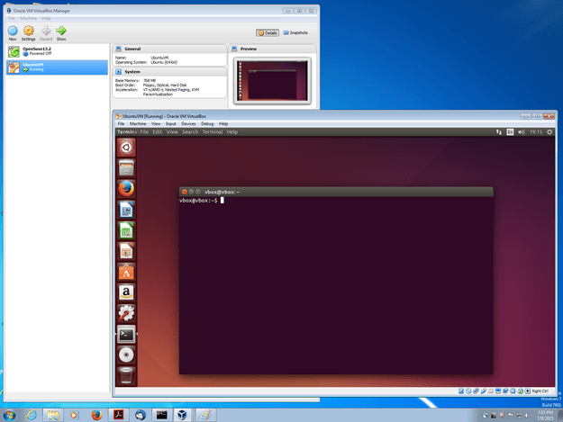

## Figure 3.1 Virtual Box (VM) with Ubuntu

## 3.5.2 UBUNTU

Ubuntu is a Linux-based operating system. It is designed for computers, smartphones, and network servers. The system is developed by a UK based company called Canonical Ltd. All the principles used to develop the Ubuntu software are based on the principles of Open Source software development.

Following are some of the significant features of Ubuntu −

* The desktop version of Ubuntu supports all the normal software on Windows such as Firefox, Chrome, VLC, etc.
* It supports the office suite called LibreOffice.
* Ubuntu has an in-built email software called Thunderbird, which gives the user access to email such as Exchange, Gmail, Hotmail, etc.
* There are a host of free applications for users to view and edit photos.
* There are also applications to manage videos and it also allows the users to share videos.
* It is easy to find content on Ubuntu with the smart searching facility.
* The best feature is, it is a free operating system and is backed by a huge open source community.

## Release Cycle of Ubuntu

Every year there are 2 releases of Ubuntu, one in April and one in October, from Canonical. The version number normally denotes the year in which the software was released. For example, version 14.04 specifies that it was released in the year 2014 and in the month of April. Similarly, the version 16.04 specifies that it was released in the year 2016 and in the month of April. The April build every year is the more stable build, while the October build does a lot of experimentation on new features.

The official site for Ubuntu is <https://www.ubuntu.com/>

The site has all information and documentation about the Ubuntu Software. It also has the download links for both the server and desktop versions of Ubuntu.

### **Uses of Ubuntu**

Below are the Top 12 Uses of Ubuntu which are as follows:

#### **Free of Cost**

Downloading and installing Ubuntu is free, and costs only time to install it. One can just download from the internet or can create an ISO bootable disk, and after it, the environment is ready to launch. With the help of Ubuntu, one can revive old, unused or any low-performance computer system without any investment. Also, troubleshooting does not cause any penny. And one can do this with the help of the Linux environment.

It also consists of its own Office suite, named as LibreOffice. This prevents our pocket by not letting us purchasing costly licensed suites such as MS Office and others.

#### **Privacy**

In comparison to Windows, [Ubuntu provides a better option](https://www.educba.com/install-ubuntu/) for privacy and security. The best advantage of having Ubuntu is that we can acquire the required privacy and additional security without having any third party solution. Risk of hacking and various other attacks can be minimized by using this distribution.

#### **Working with Partitions of hard drives**

Linux live CD and Gparted enables to divide the hard disk into partitions. This feature is also applicable when your system is a dual or triple boot. Otherwise, the partition is helpful in migration to solid state drive or more spacious drive. Apart from this, wiping of data can be easily done in Ubuntu.

#### **User-Friendly**

Ubuntu is as easy as the [Windows operating system](https://www.educba.com/windows-operators/). There is a well-known myth about Ubuntu is that Ubuntu is developed for developers and coders only. But the actual fact is, Ubuntu is a beautiful desktop operating system and can be used by any common computer user.

#### **Accessibility**

Another great feature of Ubuntu is its ease of use. The user can easily work with various CMS of PHP such as Laravel, Magneto, WordPress and many more. Apart from PHP, Ruby, Java, Python can easily be implemented in Ubuntu. Users experience a beautiful design of desktop while accessing Ubuntu that is quite easy and efficient to use.

#### **PC performance**

Performance of a system depends on what kind of usage is. For example, if the system is used for coding, designing, testing issues or for business purposes, or for just simply use of a computer system, It is recommended. Some reasons behind this are, Ubuntu boots faster than Windows, gets less infected, provides various free of cost IDEs. Otherwise, if gaming purpose is considered, Windows and MAC are way ahead than Ubuntu.

### **Conclusion**

Ubuntu is an open source desktop operating system that is freely available and can be downloaded and installed without any hassle. Ubuntu comes with a variety of features that make it more competitive than other distribution. The number of variations in functionalities of Ubuntu, make it useful for the developer as well as the common user.

**3.5.3 PYTHON**

Python is an interpreted, object-oriented, high-level programming language with dynamic semantics. Its high-level built in data structures, combined with dynamic typing and dynamic binding, make it very attractive for Rapid Application Development, as well as for use as a scripting or glue language to connect existing components together. Python's simple, easy to learn syntax emphasizes readability and therefore reduces the cost of program maintenance. Python supports modules and packages, which encourages program modularity and code reuse. The Python interpreter and the extensive standard library are available in source or binary form without charge for all major platforms, and can be freely distributed.

Often, programmers fall in love with Python because of the increased productivity it provides. Since there is no compilation step, the edit-test-debug cycle is incredibly fast. Debugging Python programs is easy: a bug or bad input will never cause a segmentation fault. Instead, when the interpreter discovers an error, it raises an exception. When the program doesn't catch the exception, the interpreter prints a stack trace. A source level debugger allows inspection of local and global variables, evaluation of arbitrary expressions, setting breakpoints, stepping through the code a line at a time, and so on. The debugger is written in Python itself, testifying to Python's introspective power. On the other hand, often the quickest way to debug a program is to add a few print statements to the source: the fast edit-test-debug cycle makes this simple approach very effective.

Python programs are very similar to text files; they can be written with something as simple as a basic text editor. The choice of available editors varies by the operating system in use. Let’s have a look at how we can run a Python script in Linux.

## Running a Script

Once the script has been written, save it to a specific location in your system and then follow the steps below to run it:

* Open the terminal by searching for it in the dashboard or pressing Ctrl + Alt + T.
* Navigate the terminal to the directory where the script is located using the cd command.
* Type python SCRIPTNAME.py in the terminal to execute the script.

## Alternate method

If you find it cumbersome to write python in the terminal every time you run the script, follow the procedure below:

* Prepend #! /usr/bin/python with your script.
* Run the following command in your terminal to make the script executable: chmod +x SCRIPTNAME.py
* Now, ​simply type ./SCRIPTNAME.py to run the executable script.

**3.5.4 FFMPEG**

ffmpeg is a very fast video and audio converter that can also grab from a live audio/video source. It can also convert between arbitrary sample rates and resize video on the fly with a high quality polyphase filter.

ffmpeg reads from an arbitrary number of input "files" (which can be regular files, pipes, network streams, grabbing devices, etc.), specified by the -i option, and writes to an arbitrary number of output "files", which are specified by a plain output url. Anything found on the command line which cannot be interpreted as an option is considered to be an output url.

Each input or output url can, in principle, contain any number of streams of different types (video/audio/subtitle/attachment/data). The allowed number and/or types of streams may be limited by the container format. Selecting which streams from which inputs will go into which output is either done automatically or with the -map option.

To refer to input files in options, you must use their indices (0-based). E.g. the first input file is 0, the second is 1, etc. Similarly, streams within a file are referred to by their indices.

As a general rule, options are applied to the next specified file. Therefore, order is important, and you can have the same option on the command line multiple times. Each occurrence is then applied to the next input or output file. Exceptions from this rule are the global options (e.g. verbosity level), which should be specified first.

Do not mix input and output files – first specify all input files, then all output files. Also do not mix options which belong to different files. All options apply ONLY to the next input or output file and are reset between files.

In the absence of any map options for a particular output file, ffmpeg inspects the output format to check which type of streams can be included in it, viz. video, audio and/or subtitles. For each acceptable stream type, ffmpeg will pick one stream, when available, from among all the inputs.

It will select that stream based upon the following criteria:

* for video, it is the stream with the highest resolution,
* for audio, it is the stream with the most channels,
* For subtitles, it is the first subtitle stream found but there’s a caveat. The output format’s default subtitle encoder can be either text-based or image-based, and only a subtitle stream of the same type will be chosen.

In the case where several streams of the same type rate equally, the stream with the lowest index is chosen.

Data or attachment streams are not automatically selected and can only be included using -map.

Stream handling is independent of stream selection, with an exception for subtitles described below. Stream handling is set via the -codec option addressed to streams within a specific output file. In particular, codec options are applied by ffmpeg after the stream selection process and thus do not influence the latter. If no -codec option is specified for a stream type, ffmpeg will select the default encoder registered by the output file muxer.

An exception exists for subtitles. If a subtitle encoder is specified for an output file, the first subtitle stream found of any type, text or image, will be included. ffmpeg does not validate if the specified encoder can convert the selected stream or if the converted stream is acceptable within the output format. This applies generally as well: when the user sets an encoder manually, the stream selection process cannot check if the encoded stream can be muxed into the output file. If it cannot, ffmpeg will abort and all output files will fail to be processed.

Some options are applied per-stream, e.g. bitrate or codec. Stream specifiers are used to precisely specify which stream(s) a given option belongs to.

A stream specifier is a string generally appended to the option name and separated from it by a colon. E.g. -codec:a:1 ac3 contains the a:1 stream specifier, which matches the second audio stream. Therefore, it would select the ac3 codec for the second audio stream.

A stream specifier can match several streams, so that the option is applied to all of them. E.g. the stream specifier in -b:a 128k matches all audio streams.

An empty stream specifier matches all streams. For example, -codec copy or -codec: copy would copy all the streams without reencoding.

Possible forms of stream specifiers are:

**stream_index**

Matches the stream with this index. E.g. -threads:1 4 would set the thread count for the second stream to 4. If stream_index is used as an additional stream specifier (see below), then it selects stream number stream_index from the matching streams. Stream numbering is based on the order of the streams as detected by libavformat except when a program ID is also specified. In this case it is based on the ordering of the streams in the program.

**stream_type[:additional_stream_specifier]**

stream_type is one of following: ’v’ or ’V’ for video, ’a’ for audio, ’s’ for subtitle, ’d’ for data, and ’t’ for attachments. ’v’ matches all video streams, ’V’ only matches video streams which are not attached pictures, video thumbnails or cover arts. If additional_stream_specifier is used, then it matches streams which both have this type and match the additional_stream_specifier. Otherwise, it matches all streams of the specified type.

**3.5.5 FFPLAY**

FFplay is a very simple and portable media player using the FFmpeg libraries and the SDL library. It is mostly used as a testbed for the various FFmpeg APIs.

**3.5.6 FFPROBE**

ffprobe gathers information from multimedia streams and prints it in human- and machine-readable fashion.

For example it can be used to check the format of the container used by a multimedia stream and the format and type of each media stream contained in it.

If a url is specified in input, ffprobe will try to open and probe the url content. If the url cannot be opened or recognized as a multimedia file, a positive exit code is returned.

ffprobe may be employed both as a standalone application or in combination with a textual filter, which may perform more sophisticated processing, e.g. statistical processing or plotting.

Options are used to list some of the formats supported by ffprobe or for specifying which information to display, and for setting how ffprobe will show it.

ffprobe output is designed to be easily parsable by a textual filter, and consists of one or more sections of a form defined by the selected writer, which is specified by the print_format option.

Sections may contain other nested sections, and are identified by a name (which may be shared by other sections), and an unique name. See the output of sections.

Metadata tags stored in the container or in the streams are recognized and printed in the corresponding "FORMAT", "STREAM" or "PROGRAM_STREAM" section.

**3.5.7 HTTP-SERVER**

http-server is a simple, zero-configuration command-line static HTTP server. It is powerful enough for production usage, but it's simple and hackable enough to be used for testing, local development and learning.

**3.5.8 INSTALLATION GUIDELINES**

**SETUP VIRTUAL BOX**

<https://www.virtualbox.org/wiki/Downloads>

* Go to the above link and download the virtual box package
* Install the package in the machine

**SETUP UBUNTU**

<https://releases.ubuntu.com/18.04/>

* Go to the above link and download the iso file
* Then setup Ubuntu in virtual box using the steps given in below link
* https://www.toptechskills.com/linux-tutorials-courses/how-to-install-ubuntu-1804-bionic-virtualbox/

**INSTALLING FFMPEG**

**Step 1 – Setup FFmpeg PPA**

FFmpeg 4 is the latest available version for installation on Ubuntu. To install the latest version, you need to configure PPA on your system. Execute below command to add FFmpeg PPA on Ubuntu system.

**sudo add-apt-repository ppa:jonathonf/ffmpeg-4**

**Step 2 – Install FFmpeg on Ubuntu**

After enabling the PPA, Lets exec below commands to install ffmpeg on Ubuntu system. This will also install many packages for the dependencies.

**sudo apt-get update**

**sudo apt-get install ffmpeg**

**Step 3 – Check FFmpeg Version**

After successfully install FFmpeg, let’s check the version installed on the system.

**ffmpeg -version**

ffmpeg version 4.2.2-0york0~16.04 Copyright (c) 2000-2019 the FFmpeg developers

built with gcc 5.4.0 (Ubuntu 5.4.0-6ubuntu1~16.04.12) 20160609

**CHAPTER-4 SYSTEM DESIGN**

* 1. **SYSTEM DESIGN**
  2. **TOOL DESIGN**

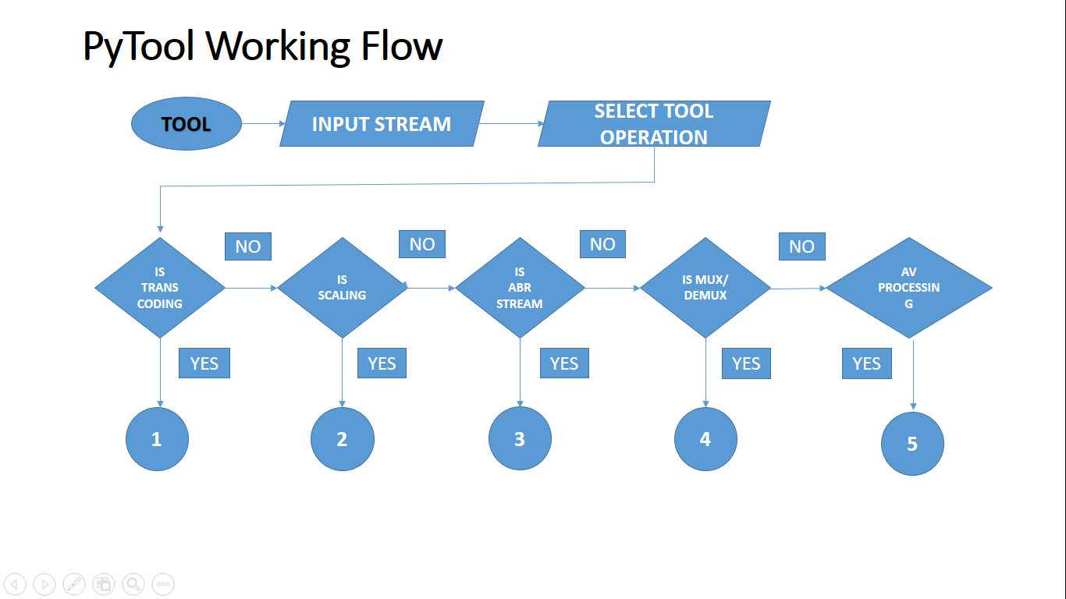

**Figure 4.1 Tool complete Flow chart – Diagram**

* 1. **TOOL INPUTS**
     1. **STREAM INPUTS**

Tool takes video streams as the main input to be provided by the user. This is the input AV stream on which tool performs the required operation to convert or generate the new stream.

User can provide stream with audio and video , audio-only, video-only . And also in any container format like mp4, webm etc. ABR streams cannot be provided as the input because the format itself is different for ABR streams.

* + 1. **SELECTING OPERATION**

User needs to select the operation to be performed on the input stream

* + - * HLS stream generation (ABR streams)
      * UP/Down Scaling
      * Transcoding
      * MUX/DEMUX
      * AV processing

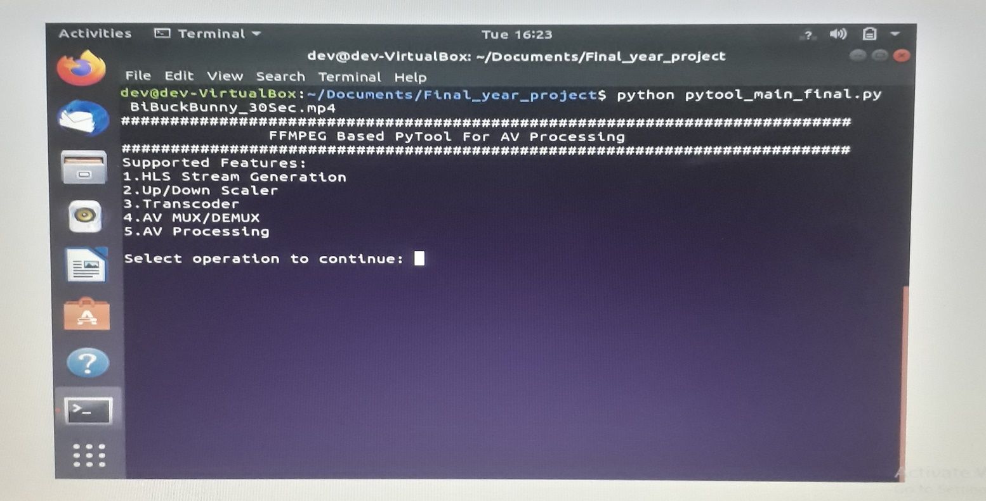

**Figure 4.2 Tool Operations selection**

**4.2.3 TOOL APPLICATIONS (What all we can do with the tool )?**

**Transcoding**

* Tool provides support for transcoding, where video or audio file can be converted from one encoding format to another.
* Eg. Stream with good quality AAC codec audio can be converted to stream with AC3(dolby) audio.

**Scaling**

* we can perform lossy and lossless compression on the input stream and generate video stream with different quality.
* It can be used for up and down scaling the video by transforming a low resolution video to higher and vice-versa.
* Eg. 1080p to 480p (down scaling) & 480p to 720p (up scaling)
* We can easily generate set of streams with different resolution & video bitrates from a single base stream.

**ABR Streaming (HLS – HTTP Live streaming)**

* we can generate streams with various bitrates for Adaptive bitrate (ABR) Streaming. HLS streams can be easily generated by this tool.
* It creates multiple minimal duration .ts (transport stream) files with different bitrates and master m3u8 file which can be used for ABR streaming

**MUX /DEMUX**

* Tool has support for muxing and demuxing AV from the original content into different output.
* That is, separating or combining the audio video streams selectively from one or more source into output stream.
* It can also be used for different container format stream generation (.mp4, .webm) etc and basic PCM audio streams.

**Handling Subtitles**

* It also provides extended support for handling subtitles in the stream. video stream can contain one or more subtitle files.
* we can remove all the subtitle file in the existing stream and generate new stream without any, extract required subtitle file for further processing, and add required subtitle file into the stream etc.

**Stream Analysis**

* We can know about the stream information like number of Audio Video streams, codec used, FPS etc using ffprobe

## TESTING THE GENERATED STREAM

## User can easily test the generated new stream with help of the tool itself. After the new stream generation tool asks the user whether we need to play the generated stream or not. If the user’s input is Y i.e yes, then video is played using ffplay . If the user presses N i.e no, then the tool simply exits.

## When the user wants to play the video, & if he/she presses Y to start the playback, then a new window is opened and video playback gets started.

## The generated stream is decoded by the ffmpeg and then decoded frames are rendered in a new window. Once the video gets completed, user can simply close the playback window and then the tool also gets exited. If user needs to work again, then tool should be started once again and then he/she can continue with the newt operation.

## 

## Figure 4.3 Stream Testing via Tool

* + 1. **USER INPUTS TO THE TOOL**

|  |  |
| --- | --- |
| **INPUT OPTIONS** | **DESCRIPTION** |
| Input stream | Stream to be converted |
| Operation ID | User selected operation ID |
| Video bitrates | Min, max , buffer bitrates for video |
| Audio bitrate | Bitrate for audio content. Eg. 48k |
| Audio options | Channel options for audio |
| CRF value | Constant rate factor or quality factor |
| Preset | Encoding speed value. Eg. Medium |
| Key frame count | Key frame position count Eg. 48 |
| Subtitle file | Input srt file for subtiltles |
| Extra Audio/Video inputs | Other AV content inputs |
| Video options | Video profile options. Eg main |
| Scaling options | Resolution values. Eg. 480p |
|  |  |

**Table 4.1 User Inputs table**

* 1. **DATA FLOW DIAGRAM**

A DFD shows what kind of information will be input to and output from the system, how the data will advance through the system, and where the data will be stored. It does not show information about process timing or whether processes will operate in sequence or in parallel, unlike a traditional structured flowchart which focuses on control flow. Overall the tool data flow is classified in to two stages. One is Input processing stage and other is output processing stage.

In the input processing stage the user input stream is taken as the video source and its decoded by the FFmpeg tool into frames. Before decoding to know the stream details this stage uses FFprobe for stream analysis. Then based on the user selected operation the decoded frames are encoded back to generate the required stream

In the output processing stage again the generated stream playback happens using the FFplay. While doing the playback the generated stream is decoded and then decoded frames are rendered.

## STAGE 1

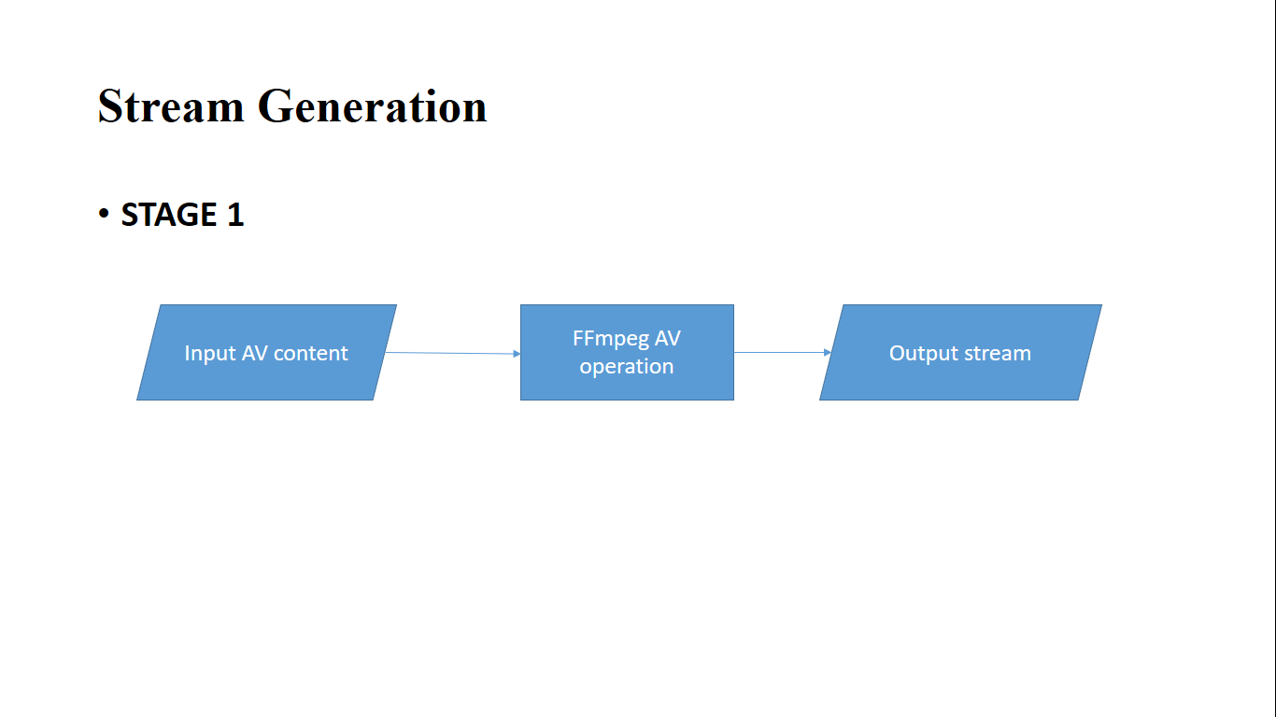

**Figure 4.4 Stream generation stage 1**

* + 1. **STAGE 2**

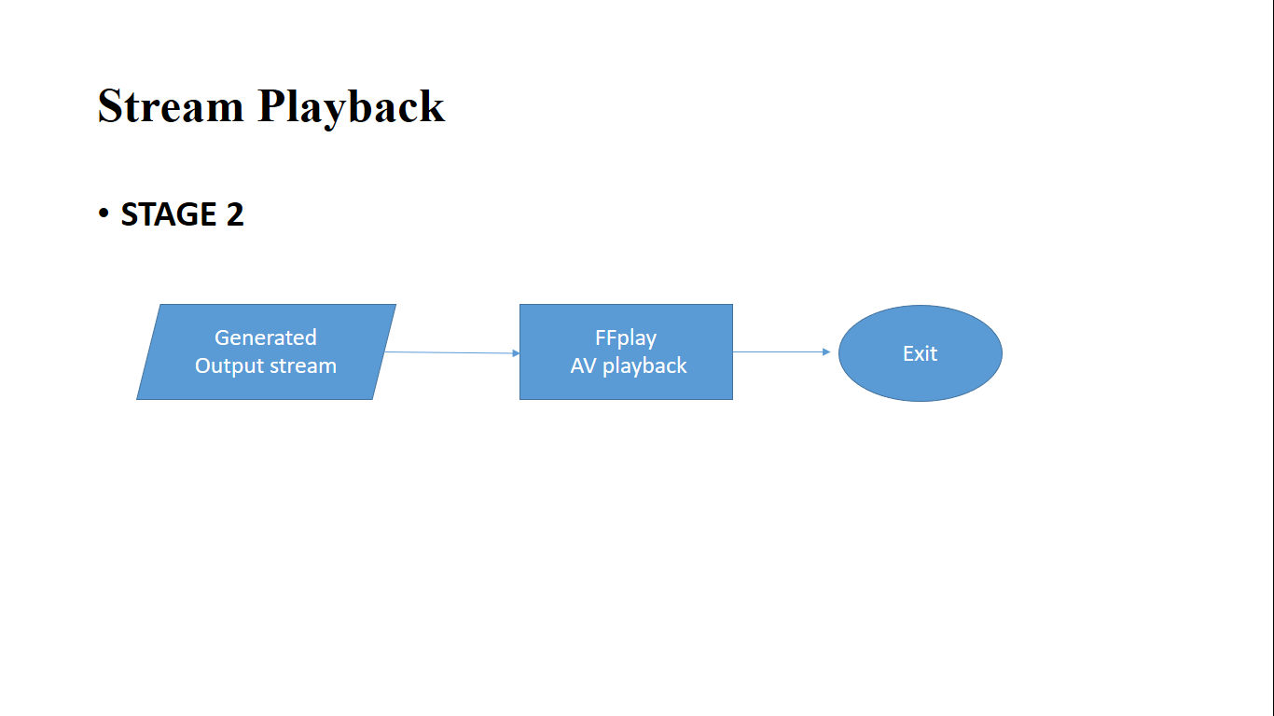

**Figure 4.5 Stream playback Stage 2**

**4.4.3 COMPLETE DATA FLOW LIFECYCLE**

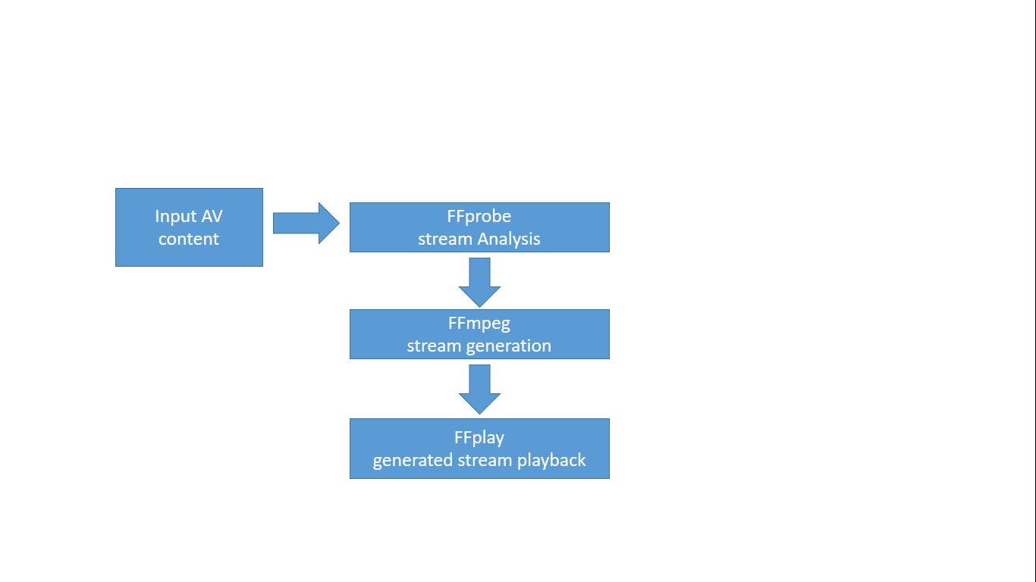

**Figure 4.6 Data flow diagram**

**CHAPTER-5 SYSTEM ARCHITECTURE**

* 1. **MODULE DESIGN SPECIFICATION**
     + ABR stream generation module
     + Transcoding module
     + Up/ Down scaling module
     + MUX / DEMUX module
     + AV processing module

## 5.1.1 MODULE DESCRIPTION

* + - 1. **ABR STREAM GENERATION MODULE**

For generating the ABR streams we need to first generate the streams with different resolutions in different bitrate and audio streams in different bitrates. After generating the different resolution & bitrate AV streams, then we should combine the different audio and video bitrate streams together as sets. Then all the generated AV content sets are represented as a m3u8 format for ABR streaming

1. Input Encoded AV content 🡪 Decoder
2. Decoder 🡪 compressed audio & video data is uncompressed here (eg. H.264, AAC codecs)
3. Scaler 🡪 changes the resolution to 1080p, 720p, 480p, 360p etc
4. Encoder 🡪 different resolution streams are combined with different bitrate audio and then encoded here
5. Generated AV content sets are combined by a HLS packager into a master.m3u8 stream for ABR streaming

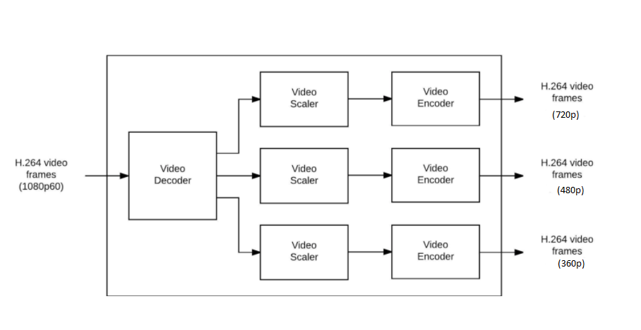

**Figure 5.1 Scaling for ABR streams**

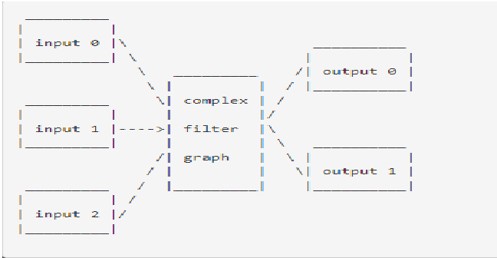

**Figure 5.2 Complex filtering**

## TRANSCODING MODULE

Converting AV stream encoded using one type of codec to another codec. That is if video is encoded as H.264_AAC, then we can convert to H.265_AC3 , this is called transcoding. Below diagram shows the architectural flow

1. Here u can see, input file is nothing but compressed Audio + Video data.
2. Demuxer 🡪 separating Audio & video data happens here
3. decoder 🡪 compressed audio & video data is uncompressed here (eg. Using h.264, aac)
4. Decoded frames is without any compression actual video & audio
5. Encoder 🡪 compresses the AV data with codec (H.265, AC3)
6. Muxer 🡪 combines the Audio data + video data
7. Now AV is converted from h.264 AAC (HD , stereo) to H.265 AC3 ( 4k, dolby)

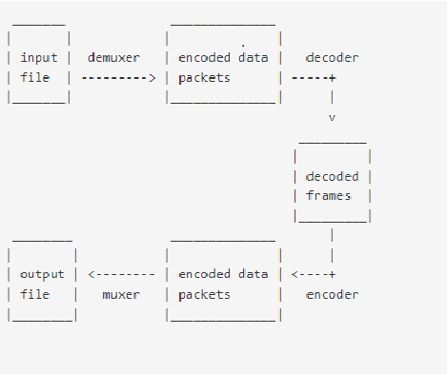

**Figure 5.3 Transcoding internals**

## UP / DOWN SCALING

## Scaling is nothing but changing the video resolution. Converting video from high resolution to lower resolution (1080p to 480p) is called down scaling Converting video from low to high resolution is called up scaling (360p to 720p).

1. Here AV compressed data using H.264 codec is taken as input. Let us consider the resolution as 1920x1080
2. Decoded 🡪 compressed audio & video data is uncompressed here (eg. Using h.264, aac)
3. Scaler 🡪 changes the resolution to 720p.
4. Encoder 🡪 Again encoding or compressing using same h.264 codec.

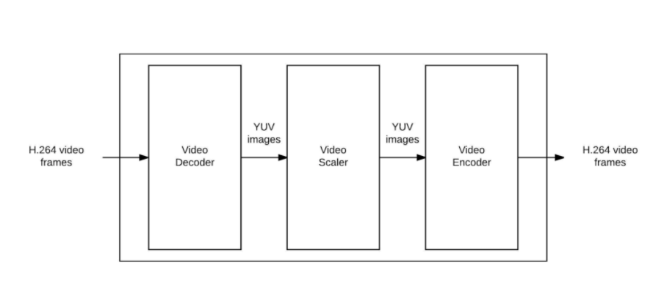

**Figure 5.4 Scaling internals**

* + - 1. **MUX / DEMUX MODULE**

1. Combining audio data with video data is called muxing
2. Separating audio and video data is called demuxing
3. Decoder 🡪 decodes the AV stream
4. Filter 🡪 Filtering only Audio or only video
5. Encoder 🡪 encodes the audio or video

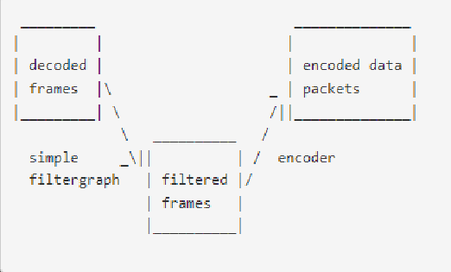

**Figure 5.5 Simple filtering**

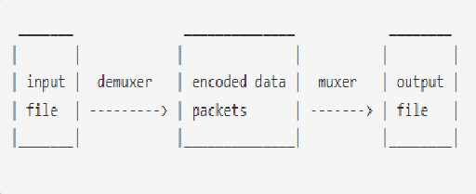

**Figure 5.6 Mux / Demux**

* + - 1. **AV PROCESSING MODULE**

This module takes care of simple video operations such as video cutting, stream analysis using FFprobe and subtitle handling. User can add or extract the subtitle file to or from the video stream.

# CHAPTER-6 SYSTEM IMPLEMENTATION

## SYSTEM IMPLEMENTATION

* 1. **MODULE EXPLANATION**
     1. **ABR STREAM GENERATION**

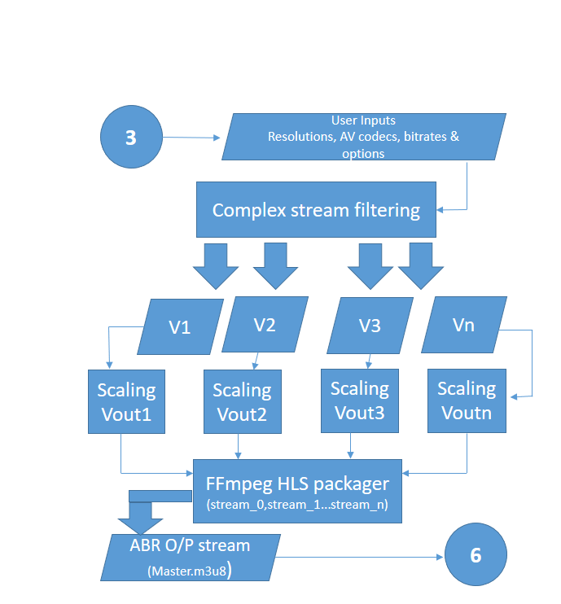

**Figure 6.1 Flowchart for HLS ABR stream generation**

**6.1.2 ABR STREAM GENERATION DESCRIPTION**

This module performs the ABR stream generation. The source input video is taken and copied into required number of streams. Each copied stream is scaled for the selected resolution. Audio is also taken and copied into n different bitrates audio stream. Then Audio and Video files are encoded and muxed as separate AV content sets. All the created AV sets are combined together by a HLS packager. HLS packager generates a m3u8 file for each resolution stream and then a master.m3u8 file. The master.m3u8 file is used for the ABR stream playback. During the ABR playback, video packets are selected based on the network speed. If the network speed is good then good resolution packets are downloaded, docoded and played or else player switches to next low quality video packet, download it and play. Based on the previous packets download speed, network speed is identified and download happens accordingly. Below figures shows the HLS stream and packet switching during playback.

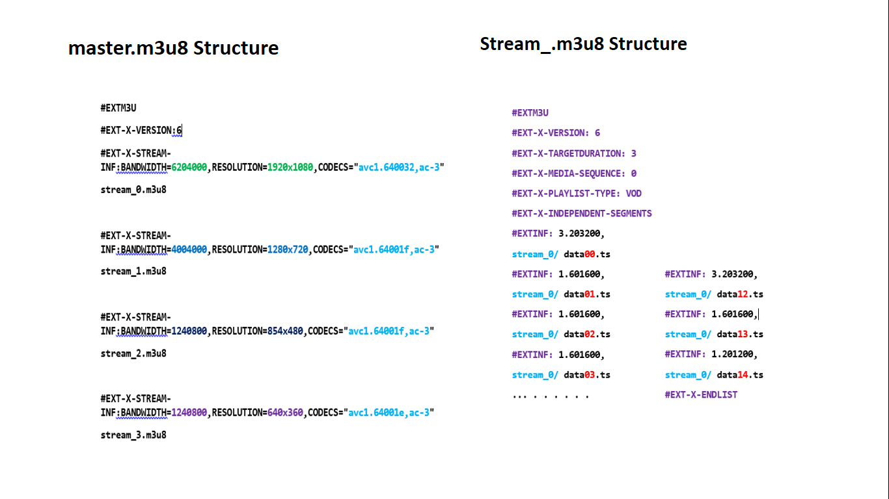

**Figure 6.2 HLS master.m3u8 output file format**

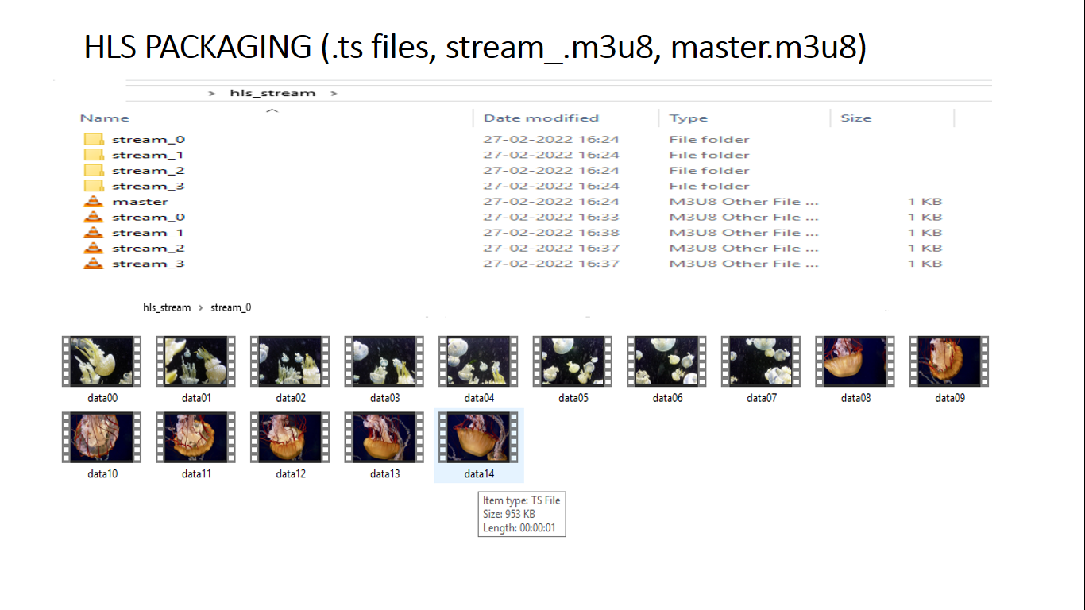

**Figure 6.3 HLS master.m3u8 output file format**

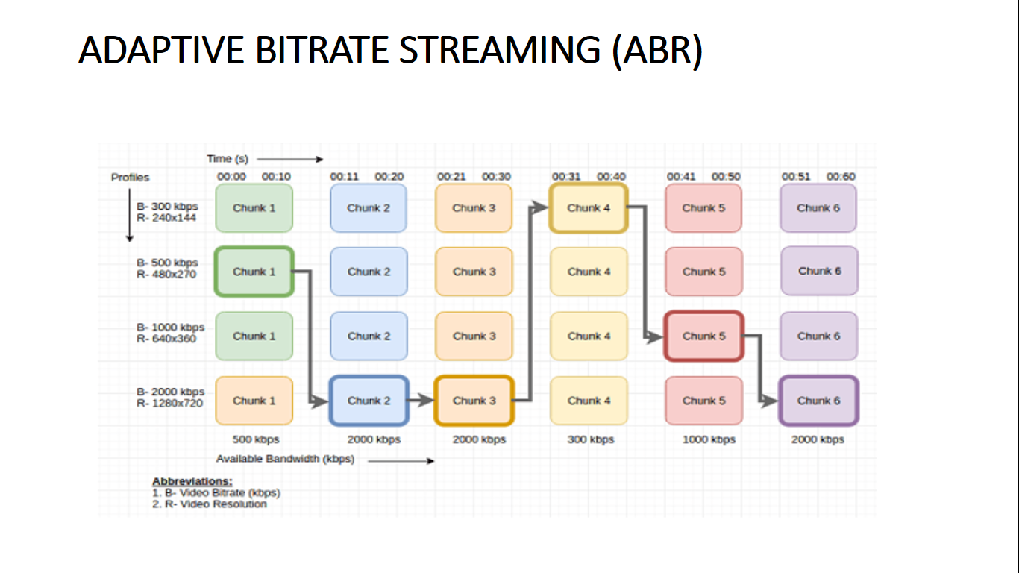

**Figure 6.4 ABR stream chuck switching**

**6.1.3 TRANSCODING**

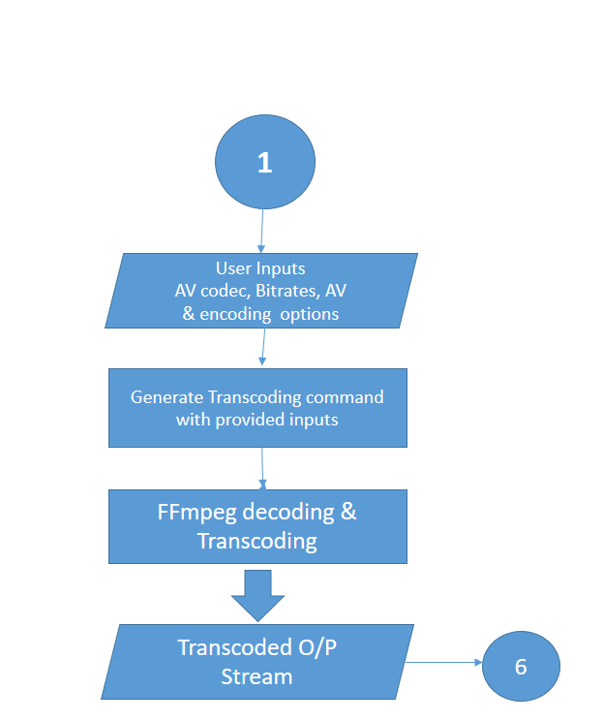

**Figure 6.5 Transcoding flow chart**

**6.1.4 TRANSCODER DESCRIPTION**

This is the module takes care of transcoding the original input video stream. The actual stream codec is identified by analyzing the stream using FFprobe. Then the module decodes the AV content into uncompressed frames. Based on the user selected codecs again the modules encodes the decoded frames with new codec to generate the transcoded stream.

Video is decoded separately and audio is decoded separately. Then video and audio contents are encoded with new codecs and then combined or muxed together.

For an example, H.264 video codec and AAC audio codec stream is decoded and then encoded with H.265 video codec and AC3 audio codec and then combined together. Thus transcoding the original stream and user can test the transcoded stream using the tool itself.

* + 1. **SCALING**

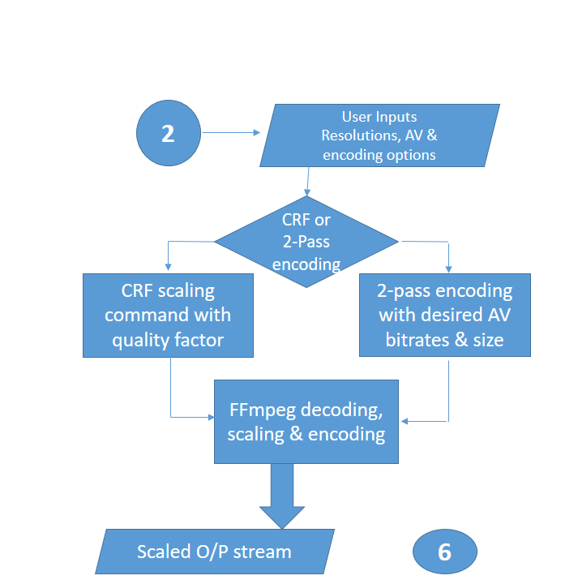

**Figure 6.6 Scaler Flow chart**

* + 1. **SCALER DESCRIPTION**

This module is responsible for adjusting the resolution of the video. If we are converting a high resolution video to low resolution video then it is called as down scaling. Eg. Converting a 1080p video to 480p video. If we are converting a low resolution video to high resolution video then its called as up scaling. Eg. Converting 1080p resolution video to 2160 (4K) video. There are 2 methods of scaling. One is CRF, where the video quality gets adjusted based on the CRF value provided. CRF 18 is the default value where user does not feel the quality reduction. Higher the CRF lower the quality. Another method is 2-pass encoding where user can scale the video with bitrate options. This method is used when we need to generate a particular file size video or bitrate video.

* + 1. **MUX/DEMUX**

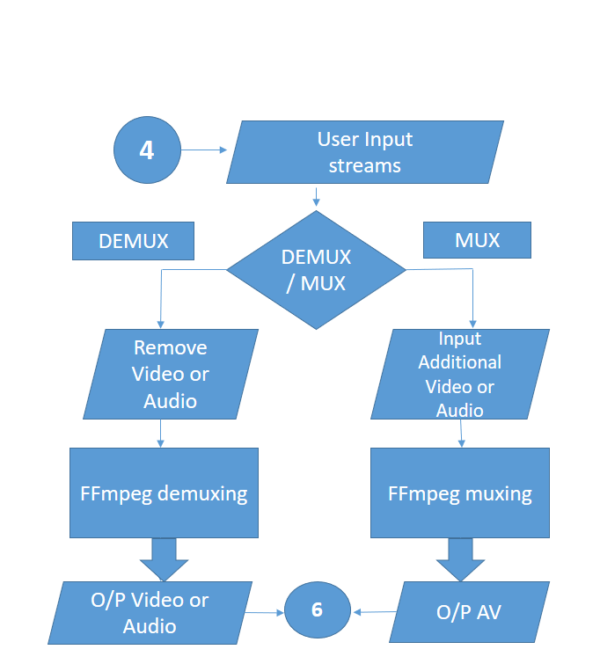

**Figure 6.7 Mux/demuxer Flow chart**

* + 1. **MUXER/DEMUXER DESCRIPTION**

Muxing is nothing but combing the encoded audio and video into a single packet stream.

Demuxing is nothing but splitting or separating the audio and video from the stream for decoding.

This module is responsible for generating Audio-only and Video-only streams, combining a video of one source with the audio of another source etc.

We can check the Audio-only or Video-only stream information using stream analysis option using FFprobe. It shows either audio or video stream information only. By this way also we can ensure the generated stream is demuxed from audio or video.

* + 1. **AV PROCESSING**

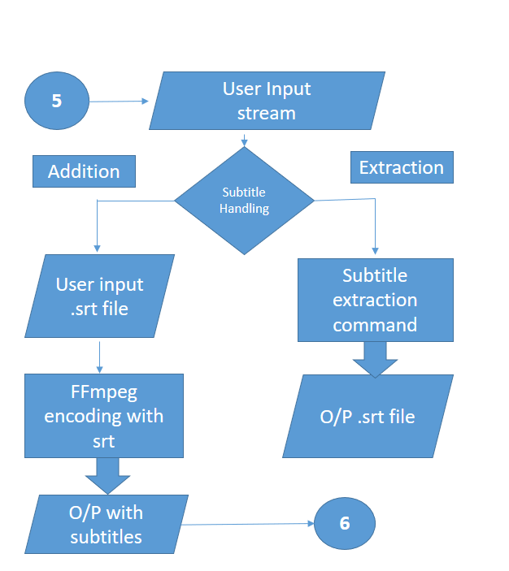

**Figure 6.8 AV handler Flow chart**

* + 1. **AV PROCESSOR DESCRIPTION**

This module is responsible for cutting the video, subtitle addition, subtitle extraction and Analysing the streams.

For adding the subtitle user needs to generate a .srt file and provide that as an input to the tool. So, that tool includes the subtitle while encoding the video and generate a video with subtitle.

When a subtitled video is provided as an input to the tools, then subtitle stream is extracted into a .srt file.

Stream analysis is done using FFprobe. It gives details such as audio codec, video codec, number of streams, bitrate, duration, start time, end time etc.

**SAMPLE SRT FILE (SUBTITLE)**

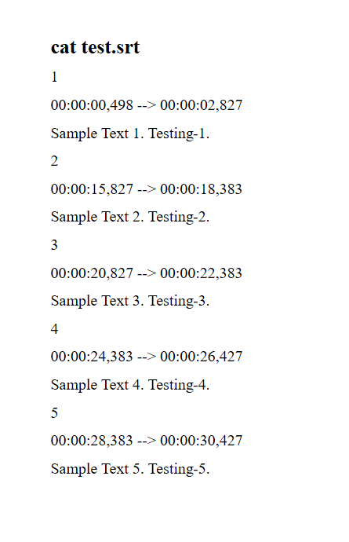

**Figure 6.9 Subtitle .srt file**

Here the .srt file shows the subtitles that should be displayed during the video playback. Subtitle should be represented in above format only. Numbers 1,2,3..so on indicates the subtitle numbers or ids. Timing info indicates the start and end time for each subtitle text. 00:00:15:827 represent 0hours, o mins, 15th second and 827 milli seconds. HH:MM:SS:ms is the time format that should be followed.

Below the time stamp the actual text to be displayed is mentioned. For different language subtitle, separate .srt files should be generated and then subtitles files should be included in the main stream.

Video can contain n number of subtitle streams in different languages and the player can play the selected language track.

Using the stream analysis option one can see the number of streams i.e subtitle tracks in the main stream using FFprobe.

**CHAPTER-7 SYSTEM TESTING**

**7. SYSTEM TESTING**

* 1. **TOOL TESTING**

Tool is completely tested by performing all the supported operations. Also the generated streams are played using the tool and tested.

Each module is tested by performing the individual operations such as HLS stream generation, transcoding, scaling, muxing, demuxing, subtitle addition, extracting & stream analysis.

Below sections has the input and output details.

## TEST CASES & REPORTS

* + 1. **TEST CASES**

Below are the test cases and the outputs screenshots attached.

**Table 7.1 Test cases for map application**

|  |  |  |  |
| --- | --- | --- | --- |
| **S. No** | **Test case** | **Test Steps** | **Test Result** |
| 1 | Generate a HLS ABR stream and check whether video is playing fine | Enter the resolution options, preset, bitrate, AV options | Tool generated the HLS stream and playback is tested. |
| 2 | Transcode a H.264 AAC video to H.265 AC3 video and check whether its playing fine | Enter the video codec, audio codec, preset, encoding options | Tool transcoded the video and playback is tested |

|  |  |  |  |
| --- | --- | --- | --- |
| **S.NO** | **Test Case** | **Test Steps** | **Test Result** |
| 3. | Scale a video to different resolution and check whether its playing fine  (720p to 360p) | Enter the resolution, scaling method CRF or 2-pass encoding, bitrates, AV options if any | Tool scaled the video and playback is tested |
| 4 | MUX/DEMUX an AV content file. Test the generated stream | Enter the MUX/DEMUX option, choose audio or video , enter AV input files to be combined | Tool separated the audio and video.Tool combined the audio and video.  Streams are tested |
| 5 | Add subtitle to the AV stream and check whether subtitles are coming during playback | Enter the .srt file to be included in the stream | Tool added the subtitle to the stream and it is displayed during the playback |
| 6 | Extract the subtitle stream form the subtitled AV stream into .srt file | Enter the input stream with subtile | Tool extracted the subtitle stream and generated a .srt file and displayed it |
| 7 | Analyse any stream and check the stream details | Enter the input stream | Tool displayed all the stream information |

* 1. **TEST OUTPUTS**
     1. **HLS ABR Stream Generation output**

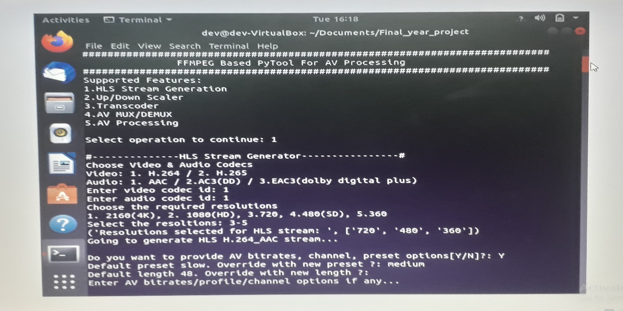

**Figure 7.1 HLS stream generation**

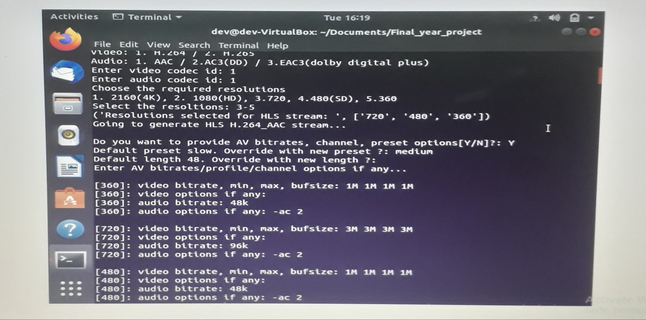

**Figure 7.2 Providing AV options for ABR stream**

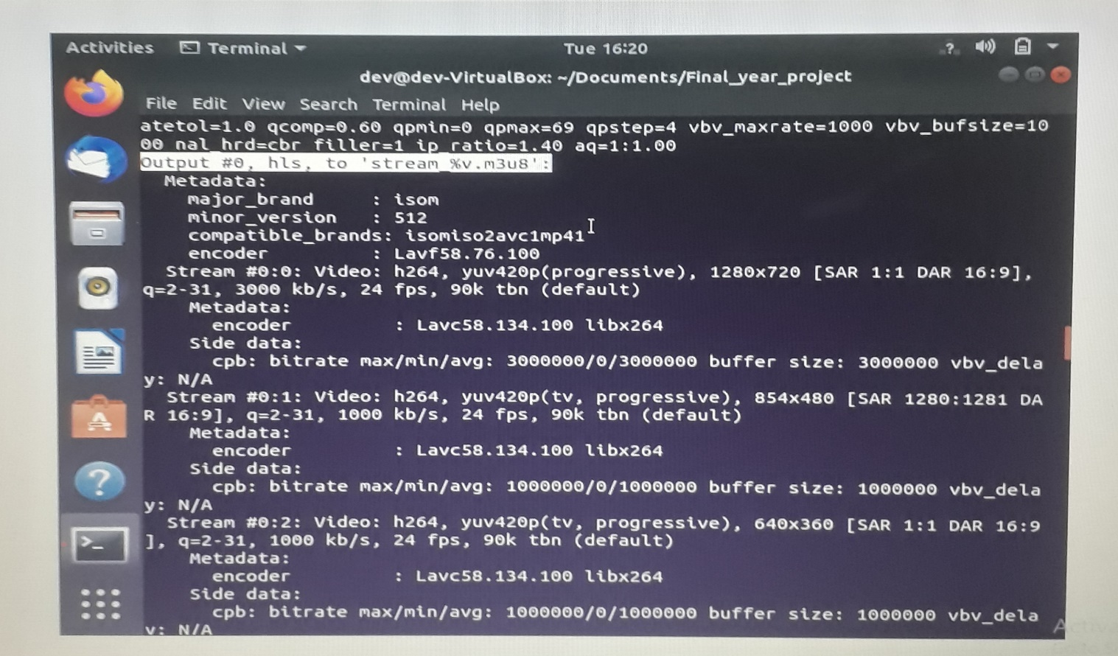

**Figure 7.3 Different resolution filtered video**

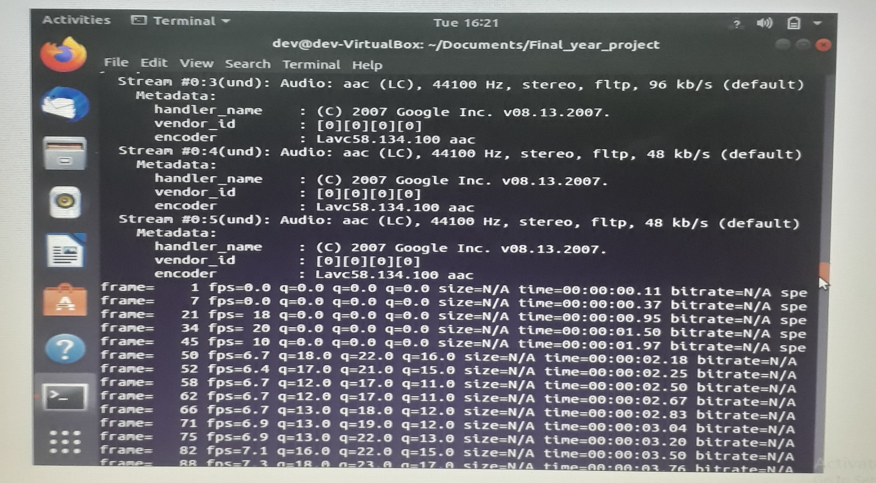

**Figure 7.4 Different bitrate audio contents**

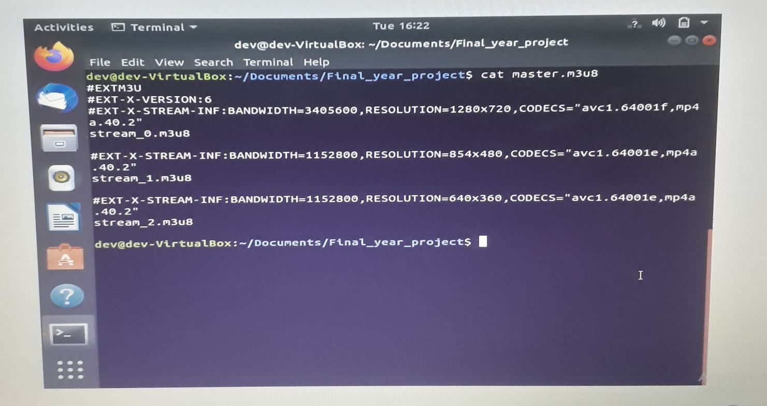

**Figure 7.5 HLS ABR master.m3u8 generated file**

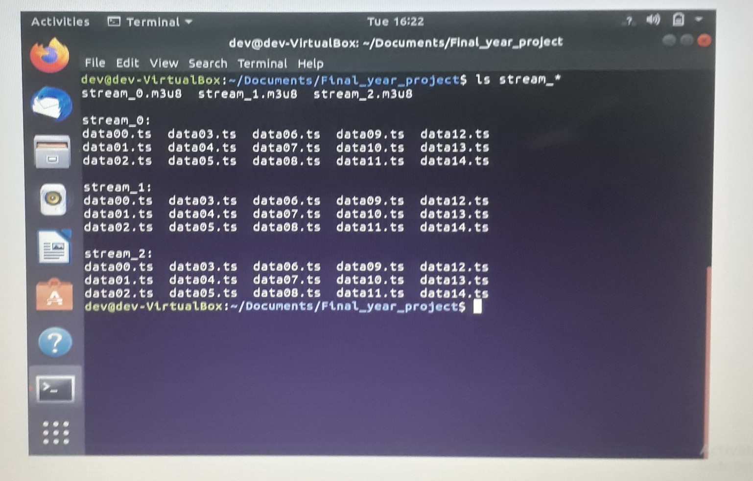

**Figure 7.6 HLS TS file (transport stream files) generated.**

**7.3.2 Transcoded Stream Generation output**

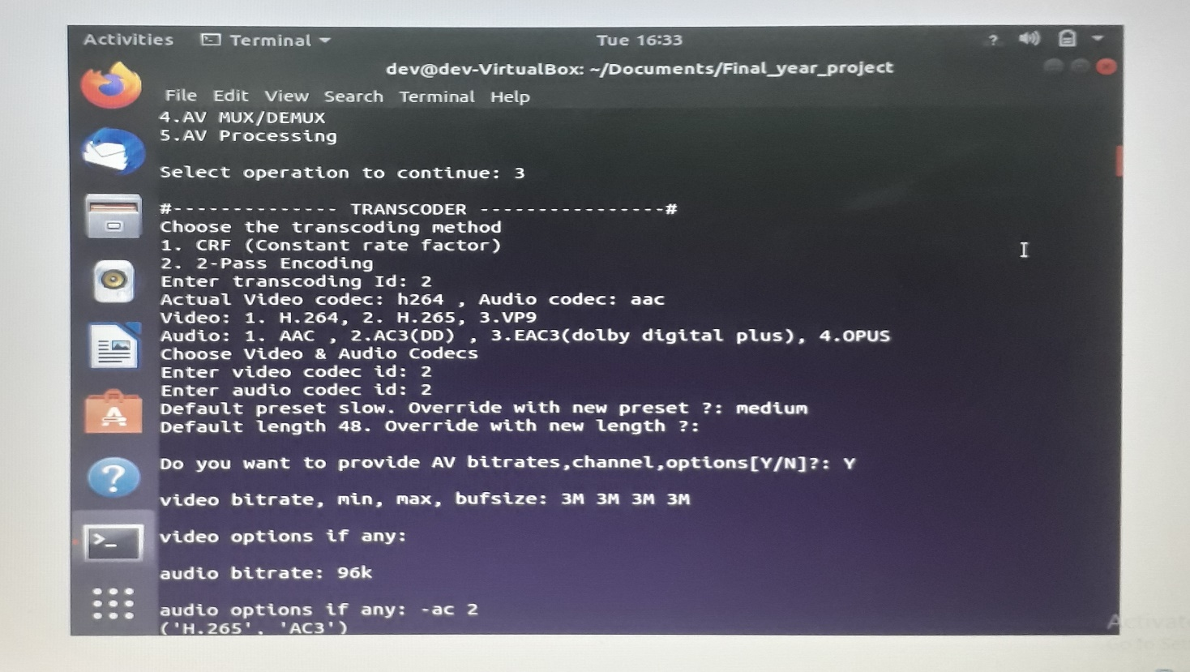

**Figure 7.7 Transcoding**

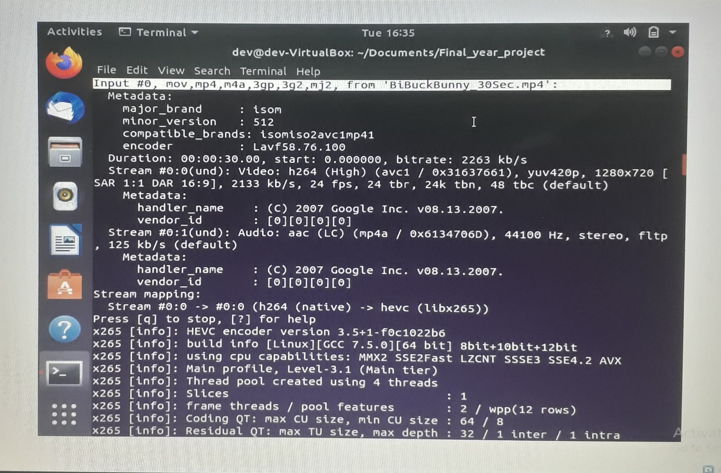

**Figure 7.8 Transcoding input h.264_aac codec stream**

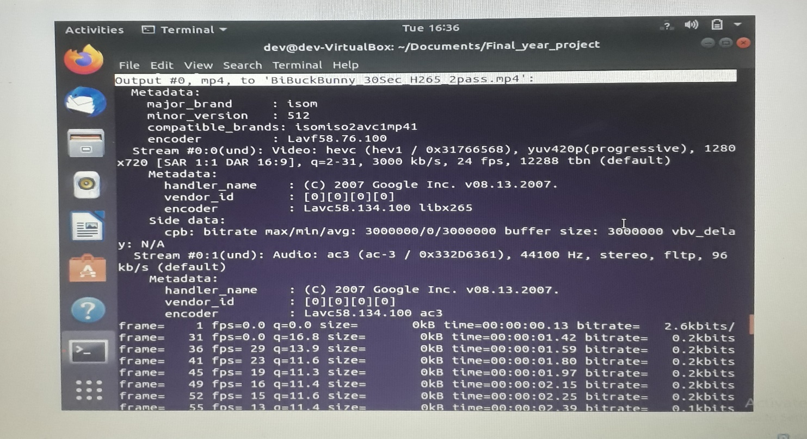

**Figure 7.9 Transcoding output h.265_ac3 codec stream**

**7.3.3 Scaling Stream Generation output**

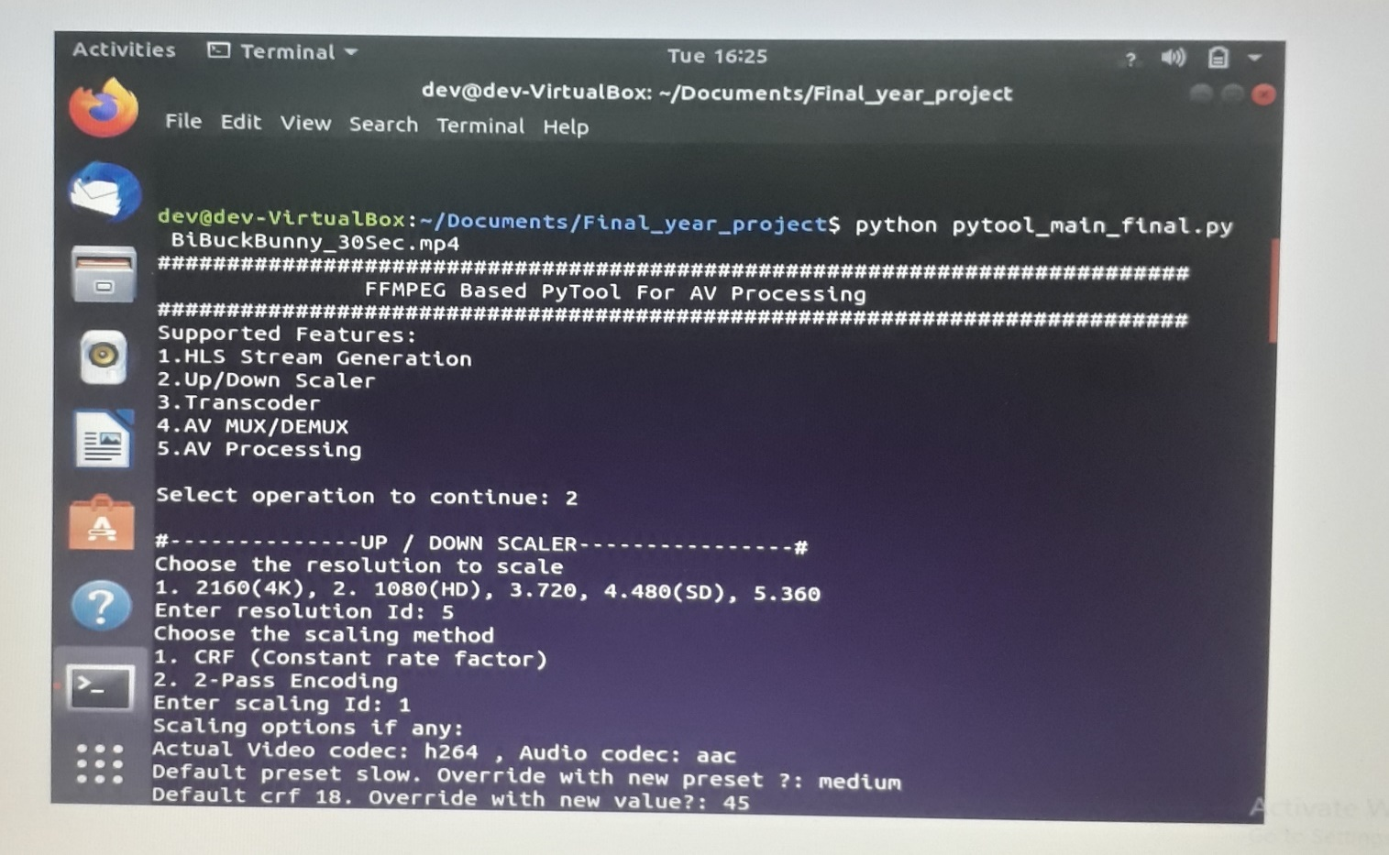

**Figure 7.10 Up/Down Scaling**

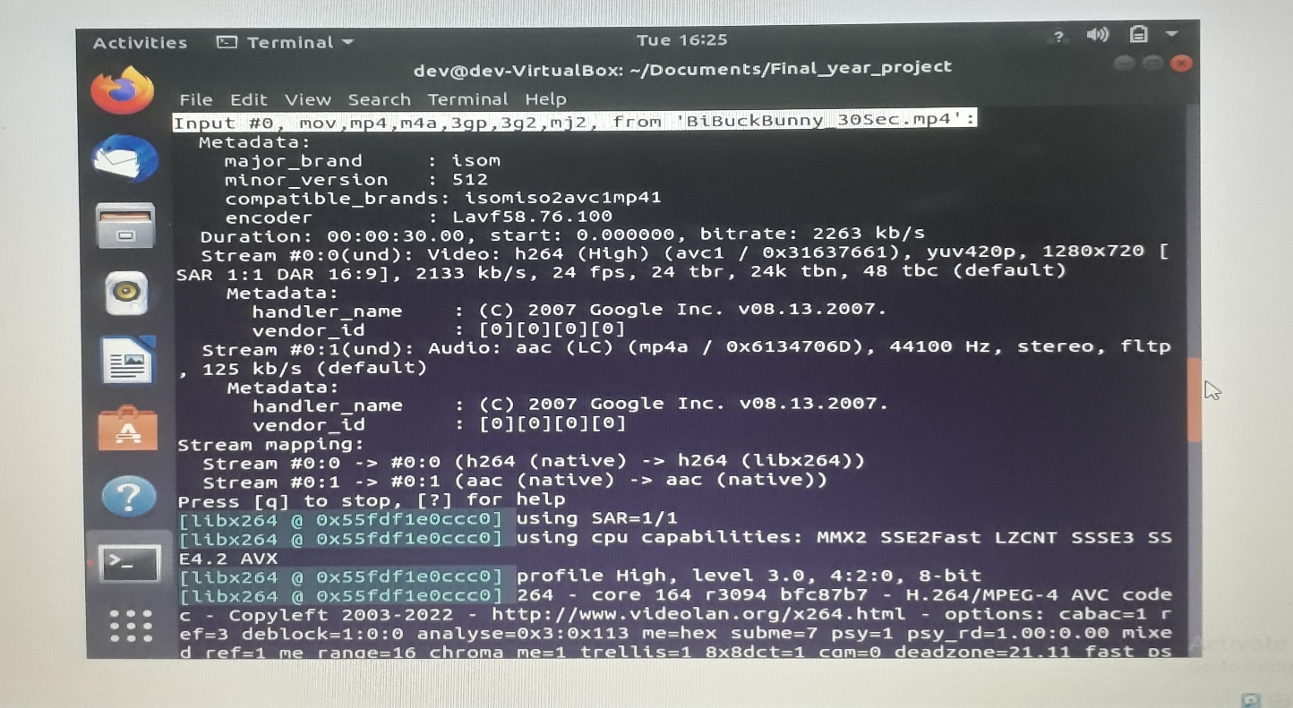

**Figure 7.11 Scaling input 1280x720p resolution stream**

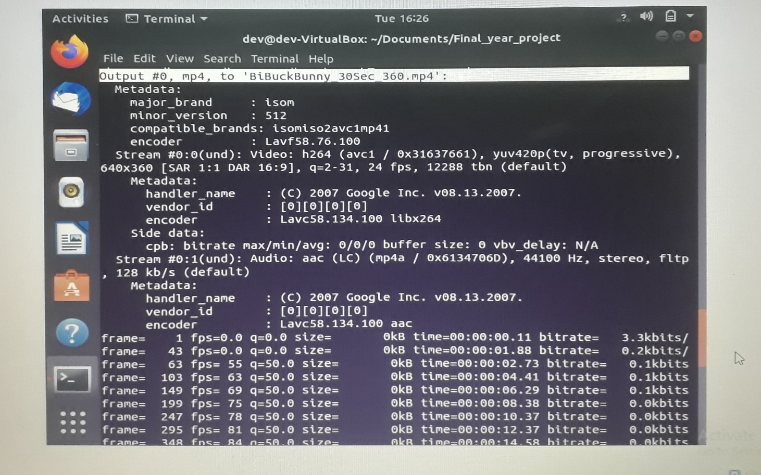

**Figure 7.12 Scaling input 640x360p resolution stream**

**7.3.4 MUX/DEMUX Stream Generation output**

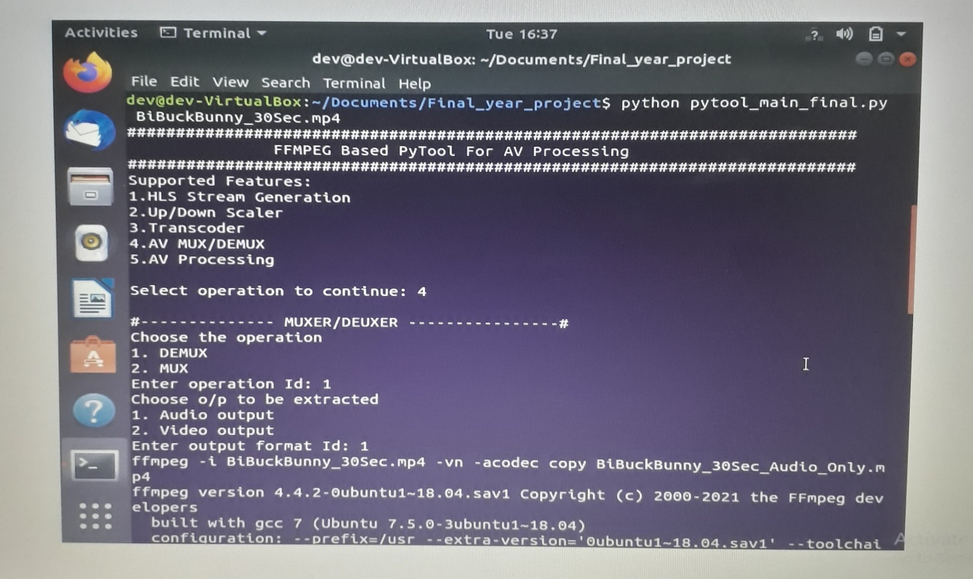

**Figure 7.13 Muxing/Demuxing**

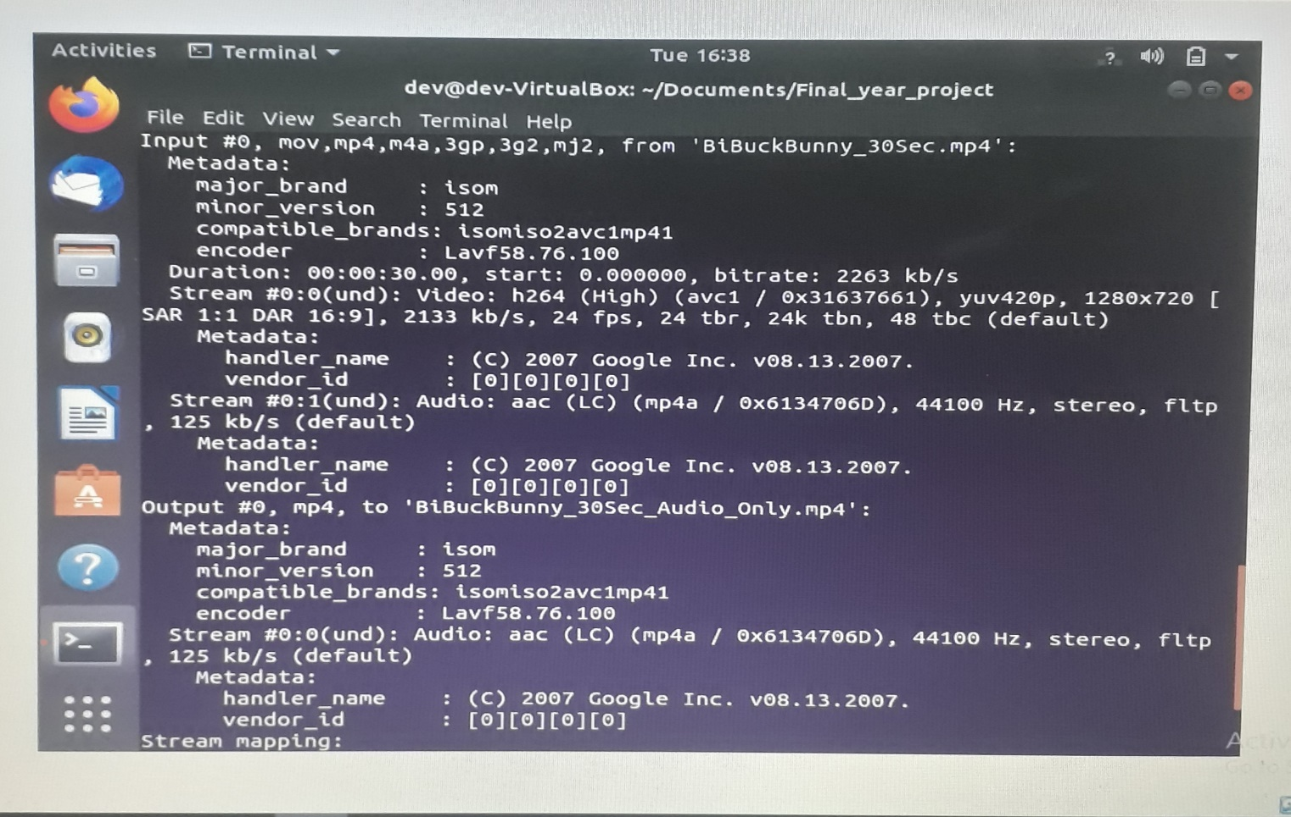

**Figure 7.14 Demuxed Audio only output generation**

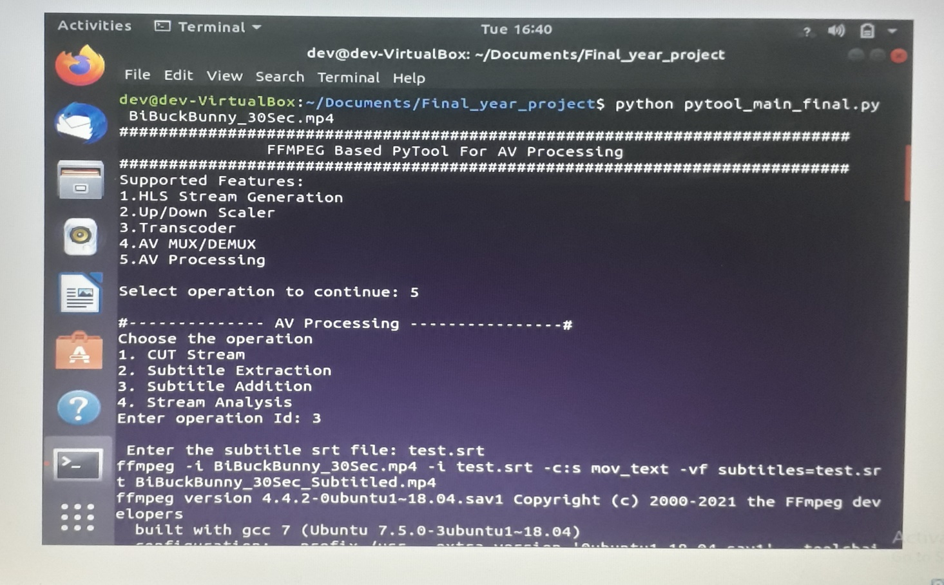

**Figure 7.15 Subtitle Handling**

**7.3.5 Subtitle Handling Stream Generation output**

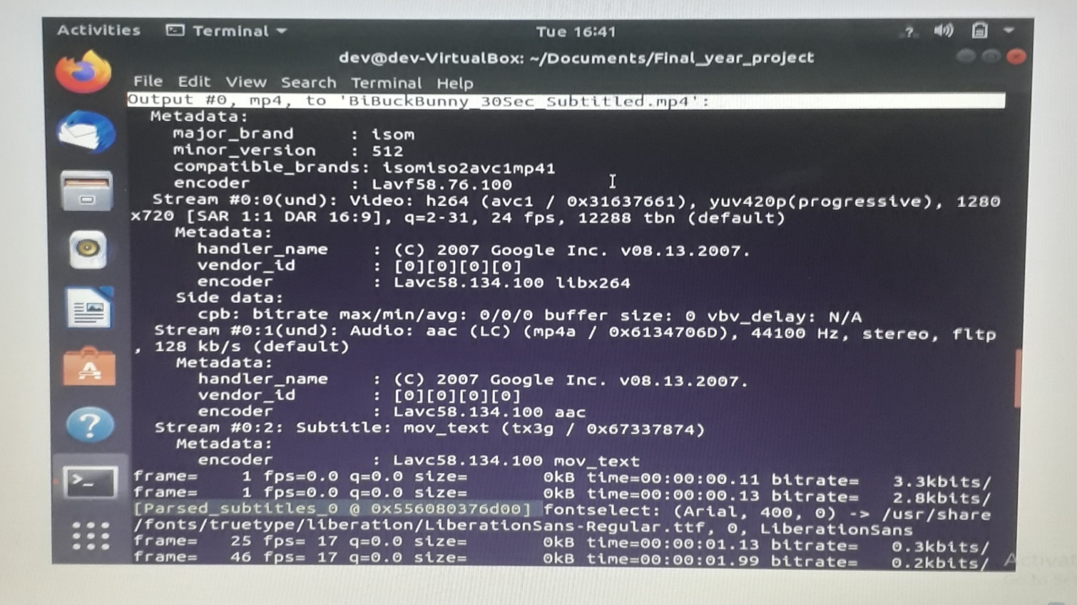

**Figure 7.16 Subtitled stream with Audio, Video & Subtitle track**

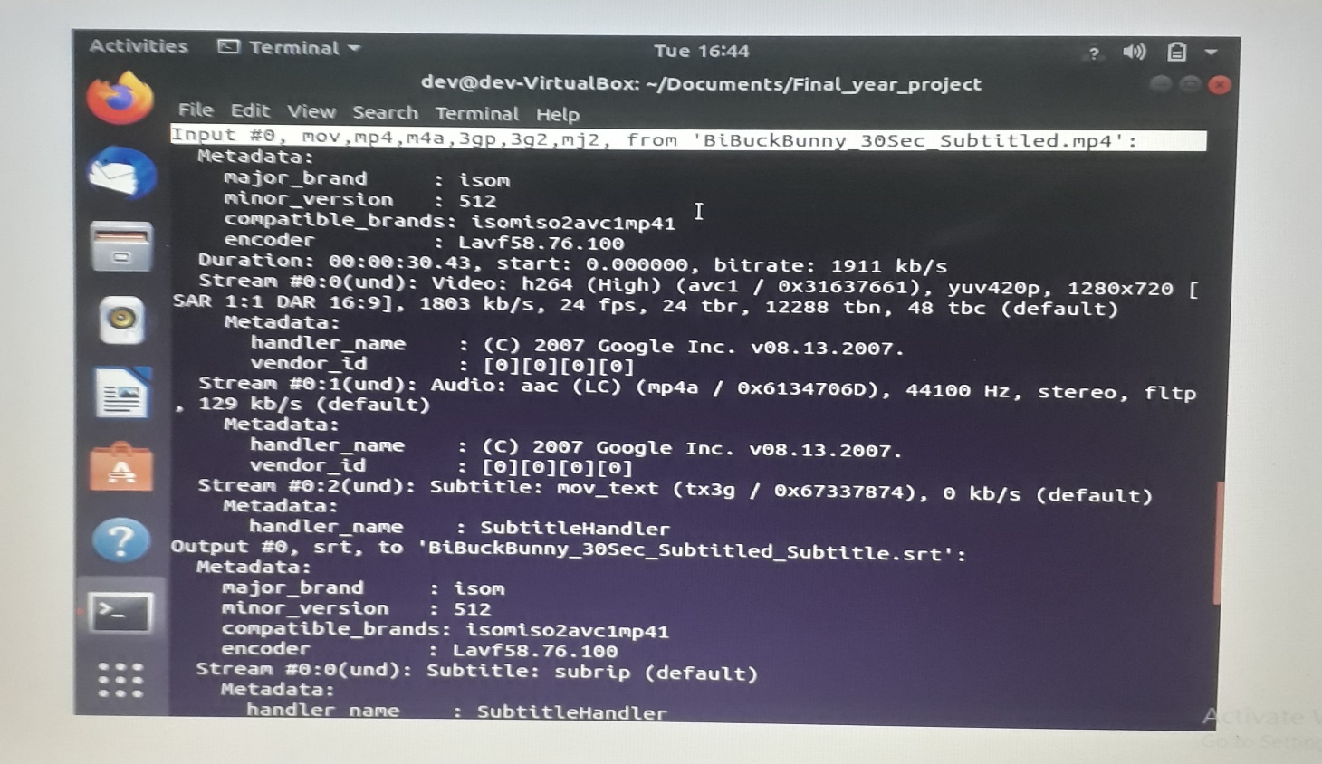

**Figure 7.17 Subtitle extraction**

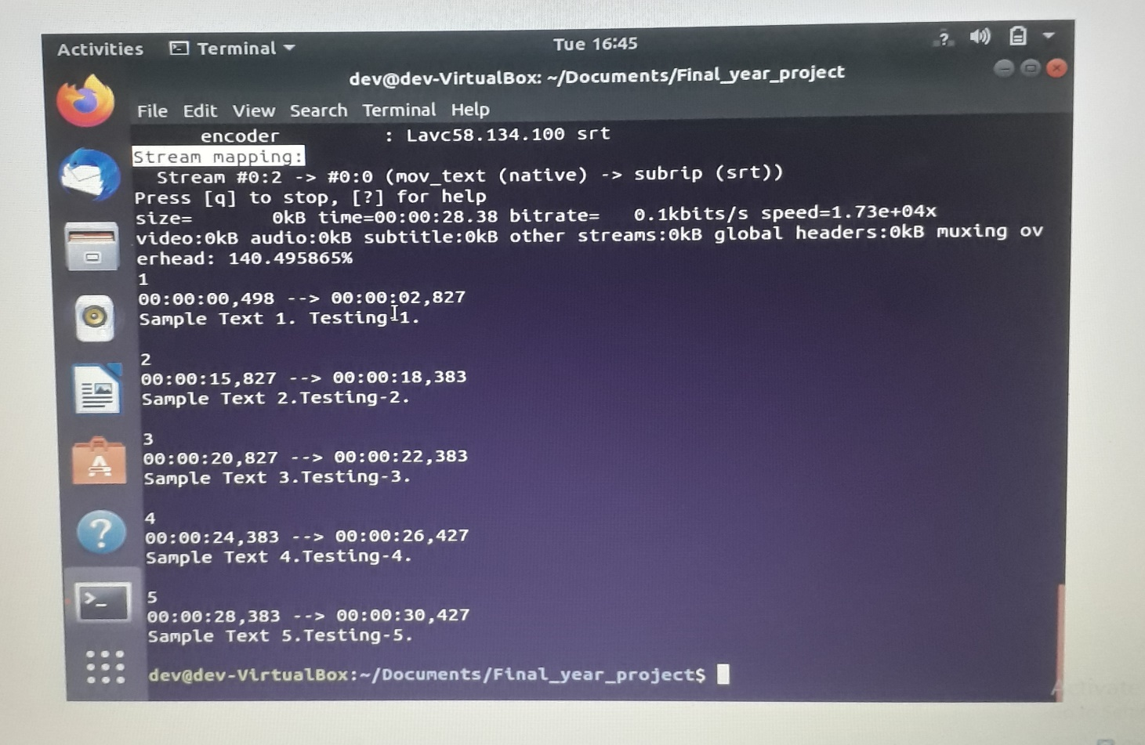

**Figure 7.18 Subtitle .srt file content**

**7.3.6 STREAM TESTING (USING VLC by HTTP-SERVER STREAMING)**

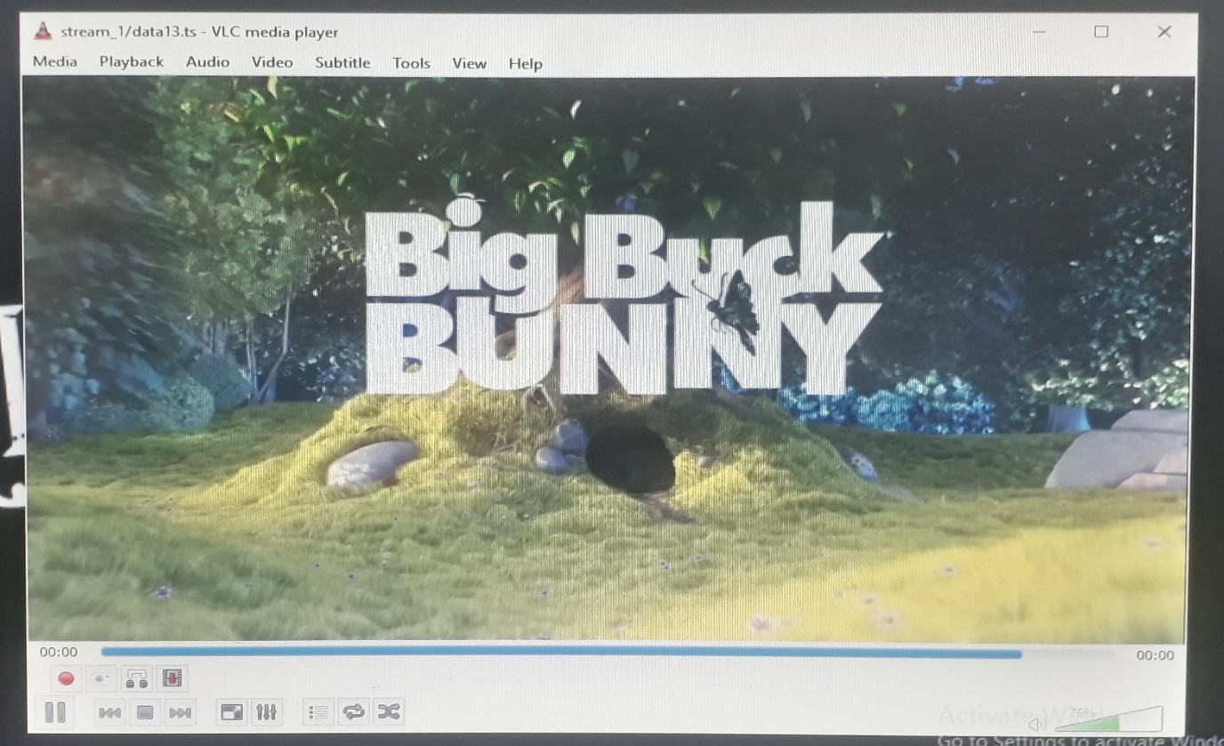

**Figure 7.19 HLS ABR stream playback (stream_1/data13.ts)**

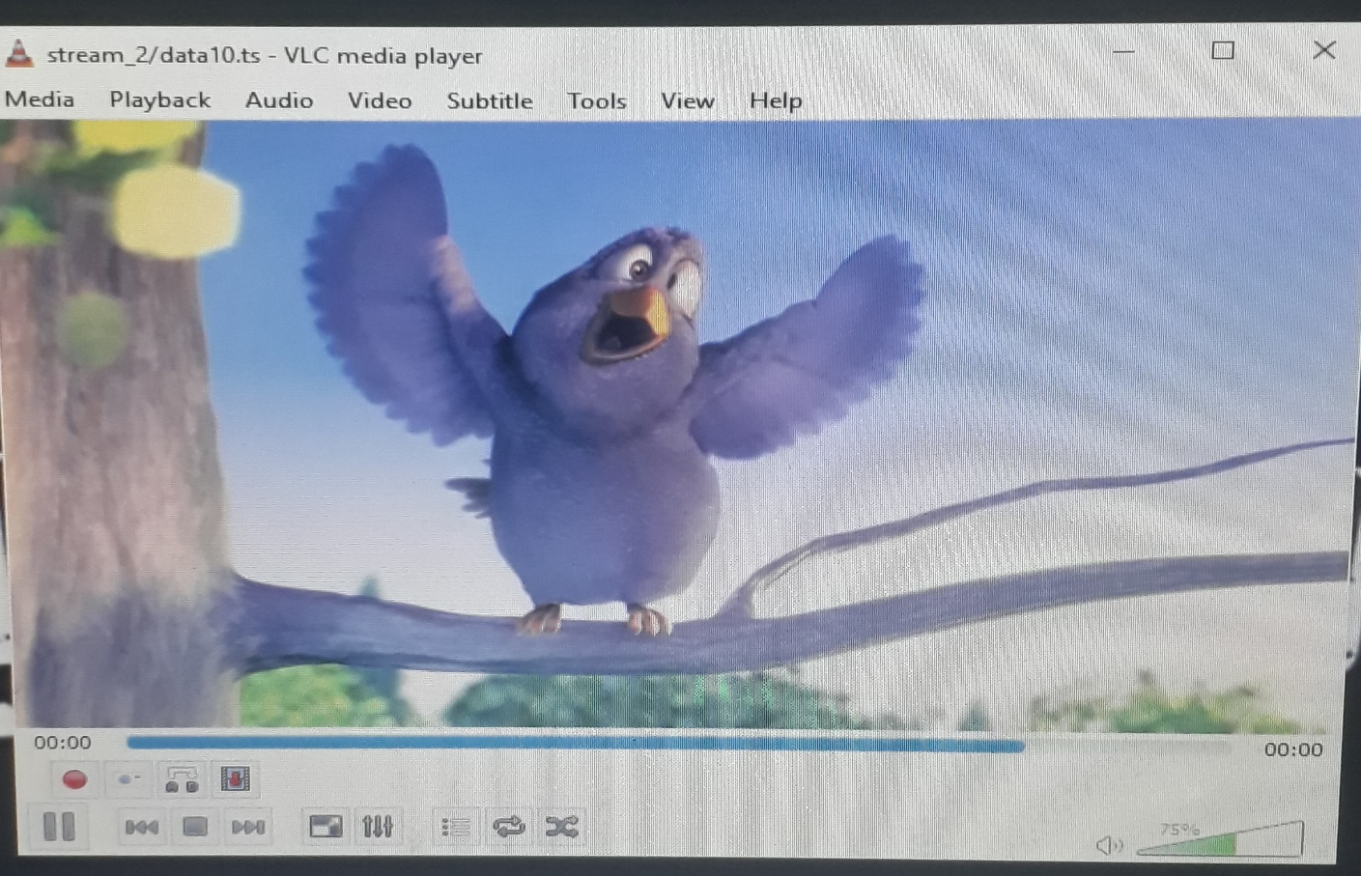

**Figure 7.20 HLS ABR stream playback (stream_2/data10.ts)**

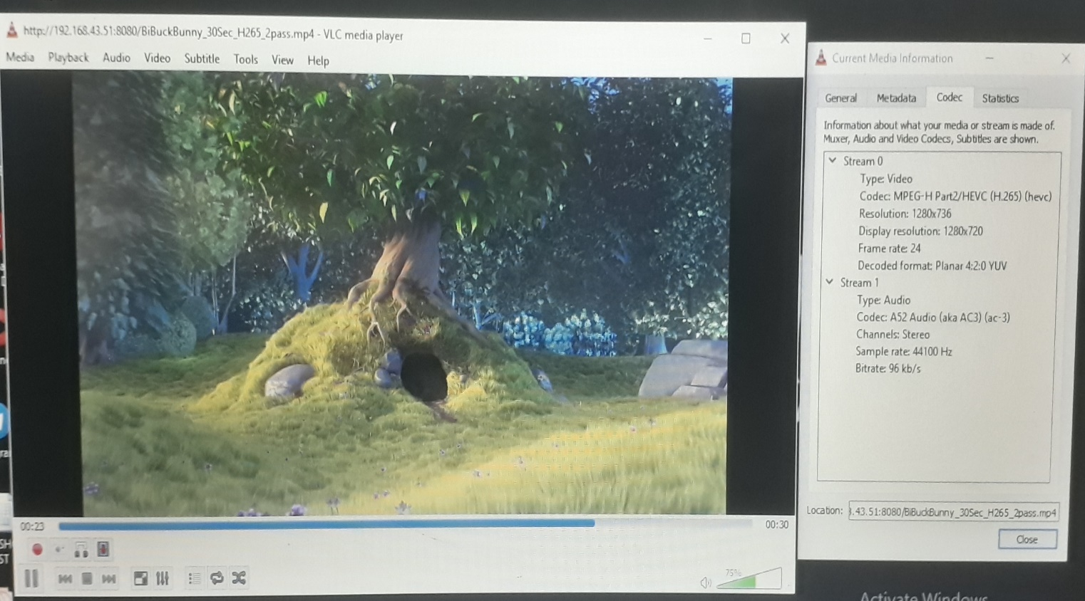

**Figure 7.21 Transcoded stream (H.265, AC3) playback**

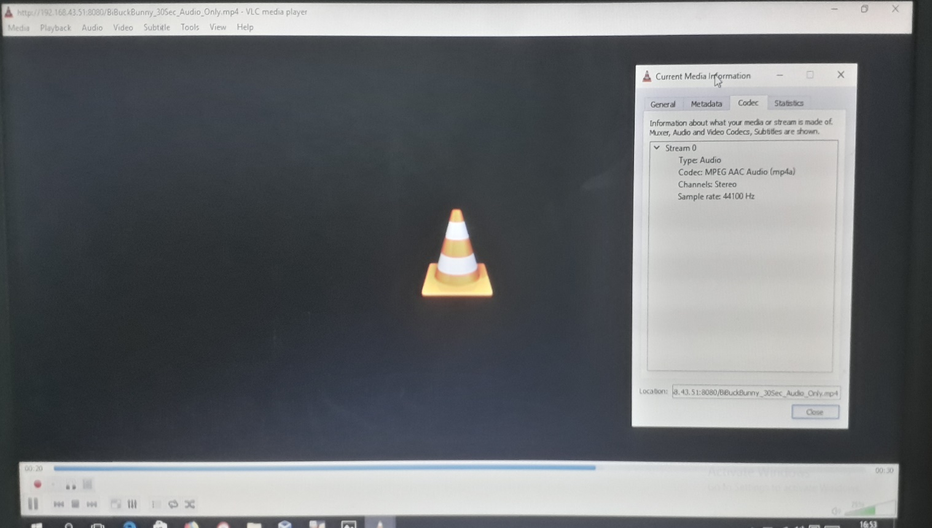

**Figure 7.22 Demuxed Audio-only stream playback**

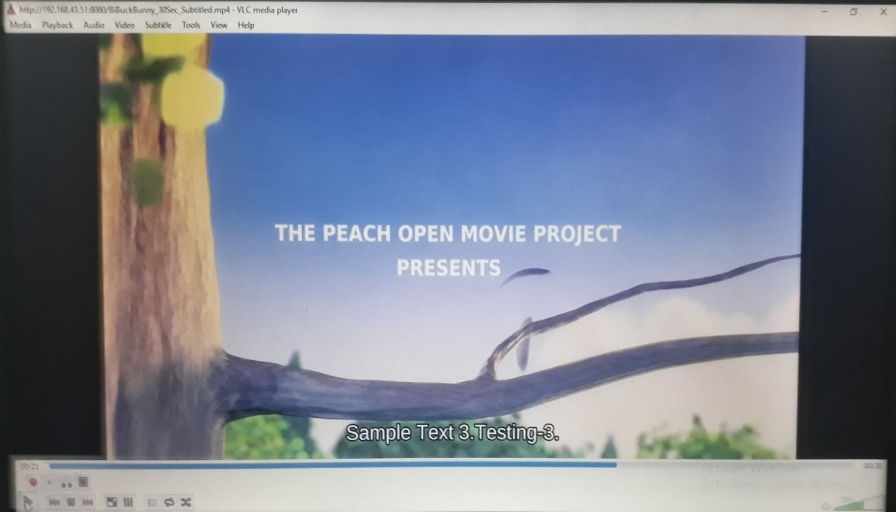

**Figure 7.23 Subtitled stream playback -1**

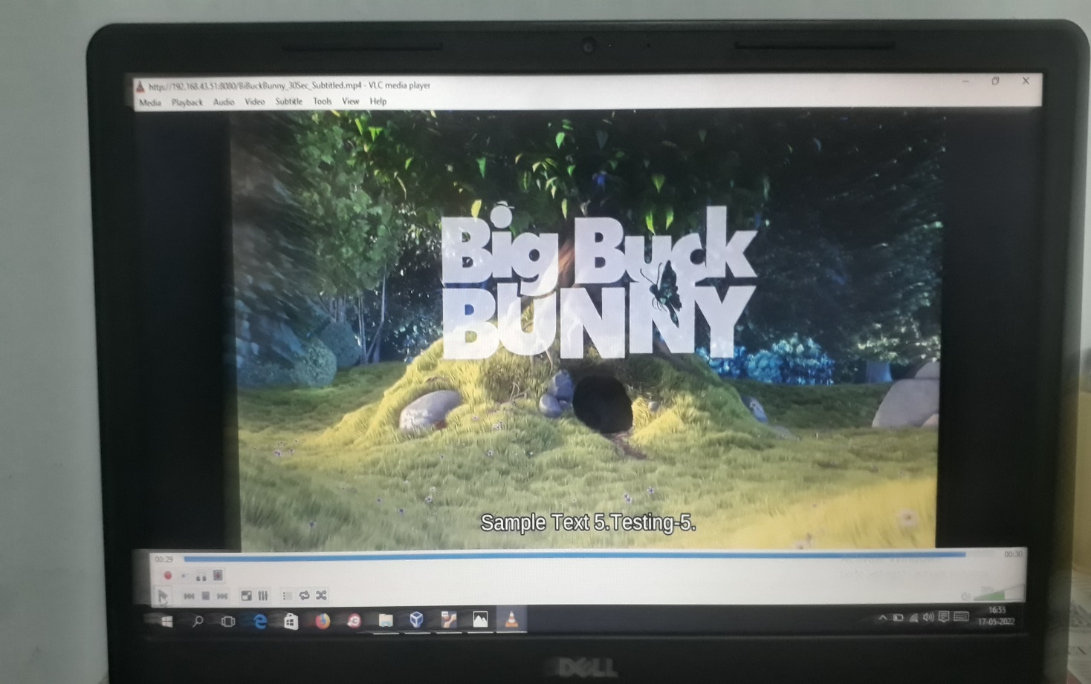

**Figure 7.24 Subtitled stream playback -2**

**CHAPTER-8 CONCLUSION**

**8. CONCLUSION**

The above proposed tool is very useful and easy for generating the required streams and the generated streams can be used for testing the video settop boxes (STBs), browsers, players, apps etc. This command line tool does not require internet for working with streams which is a major advantage of the tool. It just works with the streams available in the machine and the newly generated streams are also stored in the machine. If we are going for an UI based web app for converting the streams then we will end up in wasting so much of data for uploading the stream and downloading the generated streams. Tool worked successfully and able to generate different kinds of streams.

## PERFORMANCE ANALYSIS REPORT EXISTING SYSTEM:

* + - No single tool for multiple video operations
    - User needs more knowledge on stream generation and in-depth knowledge about ffmpeg tools
    - Time consuming process
    - Difficult to generate different kind of streams, because need to understand the process and libraries, AV options to be used.
    - Need to test the generated stream separately

## PROPOSED SYSTEM:

* + - In this project, we have implemented an all-in-one tool for easy video generation and testing.
    - Tool saves time.
    - Easy to generate any kind of streams without deep knowledge and experience in the streaming technologies
    - We can easily test the newly generated streams as well.
    - User need not to worry about the internal libraries, AV options used.

## FUTURE ENHANCEMENT

There are numerous potential future scopes and improvements for the proposed system,

1. The project emphasises the power of streaming technologies and how it helps us to test the end-user products such as TV settop boxes, browsers, apps etc.
2. The tool can be extended easily by adding more stream generation functionalities
3. Since the tool uses only open source components like ffmpeg, it can be shared as a linux package as well. So that any body can download and install the dependencies and use the tool
4. Easily anybody can contribute to the tool.

# APPENDICES

## APPENDICES

* 1. **CODING**
     1. **PYTOOL MAIN.py**

###############################################################

# FFmpeg based PyTool for easy Video transcoding and processing

###############################################################

# Module Imports

import os

import sys

import json

from subprocess import call, check_output

# Global Initianlistions

global standard_resolutions

global default_compression_opts

global default_bitrate_opts

global default_audio_bitrates

standard_resolutions = ["2160","1080","720","480","360"]

default_compression_opts = {"crf":"18","preset":"slow","keyint":"-g 48 -sc_threshold 0 -keyint_min 48"}

default_bitrate_opts = {"2160":{"vrate":"5M","min":"5M","max":"5M","buf":"10M","video_opts":"","arate":"","audio_opts":""},

"1080":{"vrate":"5M","min":"5M","max":"5M","buf":"10M","video_opts":"","arate":"","audio_opts":""},

"720" :{"vrate":"3M","min":"3M","max":"3M","buf":"3M" ,"video_opts":"","arate":"","audio_opts":""},

"480" :{"vrate":"1M","min":"1M","max":"1M","buf":"1M" ,"video_opts":"","arate":"","audio_opts":""},

"360" :{"vrate":"1M","min":"1M","max":"1M","buf":"1M" ,"video_opts":"","arate":"","audio_opts":""}}

default_audio_bitrates = {"aac":{"2160":"128k","1080":"96k","720":"96k","480":"48k","360":"48k"},

"ac3" :{"2160":"640k","1080":"640k","720":"640k","480":"640k","360":"640k"},

"ec3" :{"2160":"640k","1080":"640k","720":"640k","480":"640k","360":"640k"},

"eac3":{"2160":"640k","1080":"640k","720":"640k","480":"640k","360":"640k"}}

def get_default_opts(video_codec,audio_codec):

if video_codec.upper() in ["H.265","H265"]:

video_opts = "profile=main"

elif video_codec.upper() in ["H.264","H264"]:

video_opts = "nal-hrd=cbr:force-cfr=1"

if audio_codec.upper() == "AAC":

audio_opts = "-ac 2"

elif audio_codec.upper() in ["AC3","EC3","EAC3"]:

audio_opts = "-ac 6"

global default_bitrate_opts

for res in standard_resolutions:

default_bitrate_opts[res]["video_opts"] = video_opts

default_bitrate_opts[res]["audio_opts"] = audio_opts

default_bitrate_opts[res]["arate"] = default_audio_bitrates.get(audio_codec.lower()).get(res)

def get_codec_info(input_file,channel):

output = check_output(['ffprobe', '-v', 'error', '-select_streams', channel,

'-show_entries', 'stream=codec_name', '-of',

'default=nokey=1:noprint_wrappers=1', input_file])

#ffprobe -v error -select_streams a:0 -show_entries stream=codec_name -of default=noprint_wrappers=1:nokey=1

return output.decode('utf-8').split()

def start_play_back(src_file):

play_command = "ffplay " + src_file

os.system(play_command)

def demuxer(input_file,output_format):

basefilepath, extension = os.path.splitext(input_file)

if output_format == "Audio":

output_file = basefilepath + '_Audio_Only' + extension

dem_command = "ffmpeg -i " + input_file + " -vn -acodec copy " + output_file

print (dem_command)

os.system(dem_command)

if output_format == "Video":

output_file = basefilepath + '_Video_Only' + extension

dem_command = "ffmpeg -i " + input_file + " -an -vcodec copy " + output_file

print (dem_command)

os.system(dem_command)

play_option = raw_input("\nDo you want to play the generated stream?[Y/N]: ")

if str(play_option) == 'Y':

start_play_back(output_file)

def muxer(input_video,input_audio):

basefilepath, extension = os.path.splitext(input_video)

output_file = basefilepath + "_Audio_New" + extension

mux_command = "ffmpeg -i " + input_video + " -i " + input_audio + " -c:v copy -c:a copy -map 0:v:0 -map 1:a:0 " + output_file

print (mux_command)

os.system(mux_command)

play_option = raw_input("\nDo you want to play the generated stream?[Y/N]: ")

if str(play_option) == 'Y':

start_play_back(output_file)

def stream_cutter(input_file,duration):

basefilepath, extension = os.path.splitext(input_file)

output_file = basefilepath + "_" + str(duration) + extension

cut_command = "ffmpeg -i " + input_file + " -ss 00:00:00 -t 00:00:"+str(duration) + " -async 1 " + output_file

print (cut_command)

os.system(cut_command)

play_option = raw_input("\nDo you want to play the generated stream?[Y/N]: ")

if str(play_option) == 'Y':

start_play_back(output_file)

def subtitle_adder(input_file,srt_file):

basefilepath, extension = os.path.splitext(input_file)

output_file = basefilepath + "_Subtitled" + extension

sub_command = "ffmpeg -i " + input_file + " -i " + srt_file +" -c:s mov_text -vf subtitles="+srt_file + " " + output_file

print (sub_command)

os.system(sub_command)

play_option = raw_input("\nDo you want to play the generated stream?[Y/N]: ")

if str(play_option) == 'Y':

start_play_back(output_file)

def subtitle_extractor(input_file):

basefilepath, extension = os.path.splitext(input_file)

output_file = basefilepath + "_Subtitle.srt"

sub_command = "ffmpeg -i " + input_file + " -vn -an -codec:s srt " + output_file

print (sub_command)

os.system(sub_command)

display_command = "cat " + output_file

os.system(display_command)

def stream_analyser(input_file):

analyse_command = "ffprobe -v error -show_format -show_streams " + input_file

print (analyse_command)

os.system(analyse_command)

def transcoder(input_file,av_codec,av_info,comp_info,encoding_type="CRF"):

print "yes"

basefilepath, extension = os.path.splitext(input_file)

actual_video_codec = get_codec_info(input_file, 'v:0')

if actual_video_codec == []:

print "\n[ERROR]: No Video Codec identified in the provided stream. Exiting..."

return

actual_audio_codec = get_codec_info(input_file, 'a:0')

video_codec = av_codec["vcodec_name"]

audio_codec = av_codec["acodec_name"]

print video_codec,audio_codec

###########################################################

# Transcoding to H265/HEVC video codec

###########################################################

if video_codec in ["H.265","HEVC"]:

output_file = basefilepath + '_H265_' +audio_codec.upper()+ extension

if encoding_type == "CRF":

if 'hevc' in actual_video_codec or 'hvc1' in actual_video_codec:

default_video_opts = "-c:v copy"

print "[INFO]: Input Video is already in H265/HEVC format.Copying Video"

else:

default_video_opts = "-c:v "+av_codec["vcodec"]

compression_opts = '-tag:v hvc1 -crf '+comp_info["crf"]+' -preset '+comp_info["preset"]

if actual_audio_codec != []:

if audio_codec.lower() in actual_audio_codec:

default_audio_opts = "-c:a copy"

print "[INFO]: Input Audio is already in %s format.Copying Audio" %(audio_codec)

else:

default_audio_opts = ' -c:a '+av_codec["acodec"]

else:

print "[INFO]: Input Stream has no Audio. Skipping"

default_audio_opts = ""

transcoder_command = 'ffmpeg -i '+input_file+' '+ default_video_opts+' '+compression_opts+' '+default_audio_opts+' '+output_file

print transcoder_command

os.system(transcoder_command)

elif encoding_type == "2-Pass":

output_file = basefilepath + '_H265_2pass' + extension

if av_info["vrate"] != None:

video_bitrate_info = '-b:v '+av_info["vrate"]+' -maxrate '+av_info["max"]+' -minrate '+av_info["min"]+' -bufsize '+av_info["buf"]

else:

video_bitrate_info = ""

if av_info["arate"] != None:

audio_bitrate_info = ' -b:a '+av_info["arate"]

else:

audio_bitrate_info = ""

if av_info["video_opts"] != None:

video_opts = av_info["video_opts"]

else:

video_opts = ""

if av_info["audio_opts"] != None:

audio_opts = av_info["audio_opts"]

else:

audio_opts = ""

default_video_opts = ' -c:v '+av_codec["vcodec"]+' '+video_opts+' '+video_bitrate_info

if actual_audio_codec != []:

default_audio_opts = ' -c:a '+av_codec["acodec"]+' '+audio_bitrate_info+' '+audio_opts

else:

default_audio_opts = ""

pass1_command = 'ffmpeg -y -i '+input_file+' '+default_video_opts+' -x265-params pass=1 -an -f mp4 /dev/null'

pass2_command = 'ffmpeg -i ' +input_file+' '+default_video_opts+' -x265-params pass=2 '+default_audio_opts+' '+output_file

print(pass1_command)

print(pass2_command)

os.system(pass1_command)

os.system(pass2_command)

###########################################################

# Transcoding to H264 video codec

###########################################################

if video_codec in ["H.264"]:

output_file = basefilepath + '_H264' +audio_codec.upper()+ extension

if encoding_type.lower() == "crf":

if 'avc1' in actual_video_codec:

default_video_opts = "-c:v copy"

print "[INFO]: Input Video is already in H264 format.Copying Video"

else:

default_video_opts = ' -c:v '+av_codec["vcodec"]

compression_opts = '-tag:v avc1 -crf '+comp_info["crf"]+' -preset '+comp_info["preset"]

if actual_audio_codec != []:

if audio_codec.lower() in actual_audio_codec:

default_audio_opts = "-c:a copy"

print "[INFO]: Input Audio is already in %s format.Copying Audio" %(audio_codec)

else:

default_audio_opts = ' -c:a '+av_codec["acodec"]

else:

print "[INFO]: Input Stream has no Audio. Skipping"

default_audio_opts = ""

transcoder_command = 'ffmpeg -i '+input_file+' '+ default_video_opts+' '+compression_opts+' '+default_audio_opts+' '+output_file

print transcoder_command

os.system(transcoder_command)

elif encoding_type == "2-Pass":

output_file = basefilepath + '_H264_2pass' + extension

if av_info["vrate"] != None:

video_bitrate_info = '-b:v '+av_info["vrate"]+' -maxrate '+av_info["max"]+' -minrate '+av_info["min"]+' -bufsize '+av_info["buf"]

else:

video_bitrate_info = ""

if av_info["arate"] != None:

audio_bitrate_info = ' -b:a '+av_info["arate"]

else:

audio_bitrate_info = ""

if av_info["video_opts"] != None:

video_opts = av_info["video_opts"]

else:

video_opts = ""

if av_info["audio_opts"] != None:

audio_opts = av_info["audio_opts"]

else:

audio_opts = ""

default_video_opts = ' -c:v '+av_codec["vcodec"]+' '+video_opts+' '+video_bitrate_info

if actual_audio_codec != []:

default_audio_opts = ' -c:a '+av_codec["acodec"]+' '+audio_bitrate_info+' '+audio_opts

else:

default_audio_opts = ""

pass1_command = 'ffmpeg -y -i '+input_file+' '+default_video_opts+' -x264-params pass=1 -an -f mp4 /dev/null'

pass2_command = 'ffmpeg -i ' +input_file+' '+default_video_opts+' -x264-params pass=2 '+default_audio_opts+' '+output_file

print(pass1_command)

print(pass2_command)

os.system(pass1_command)

os.system(pass2_command)

###########################################################

# Transcoding to VP9 video codec

###########################################################

if video_codec in ["VP9"]:

output_file = basefilepath + '_VP9_'+audio_codec.upper()+'.webm'

if encoding_type == "2-Pass":

if av_info["vrate"] != None:

video_bitrate_info = '-b:v '+av_info["vrate"]+' -maxrate '+av_info["max"]+' -minrate '+av_info["min"]+' -bufsize '+av_info["buf"]

else:

video_bitrate_info = ""

if av_info["arate"] != None:

audio_bitrate_info = ' -b:a '+av_info["arate"]

else:

audio_bitrate_info = ""

if av_info["video_opts"] != None:

video_opts = av_info["video_opts"]

else:

video_opts = ""

if av_info["audio_opts"] != None:

audio_opts = av_info["audio_opts"]

else:

audio_opts = ""

default_video_opts = ' -c:v '+av_codec["vcodec"]+' '+video_opts+' '+video_bitrate_info

#default_video_opts = video_opts + " -tile-columns 2 -g 240 -threads 8 -quality good " + " -c:v libvpx-vp9 "

if actual_audio_codec != []:

default_audio_opts = ' -c:a '+av_codec["acodec"]+' '+audio_bitrate_info+' '+audio_opts

else:

default_audio_opts = ""

vp9_pass1_command = 'ffmpeg -i '+input_file+' '+default_video_opts+' '+default_audio_opts+' -pass 1 -speed 1 '+output_file

vp9_pass2_command = 'ffmpeg -i '+input_file+' '+default_video_opts+' '+default_audio_opts+' -pass 2 -speed 1 '+output_file

print(vp9_pass1_command)

print(vp9_pass2_command)

os.system(vp9_pass1_command)

os.system(vp9_pass2_command)

play_option = raw_input("\nDo you want to play the generated stream?[Y/N]: ")

if str(play_option) == 'Y':

start_play_back(output_file)

def up_down_scaler(input_file,scaling_info,av_codec,av_info,comp_info):

basefilepath, extension = os.path.splitext(input_file)

output_file = basefilepath + '_' + scaling_info["selected_resolution"] + extension

res = scaling_info["selected_resolution"]

if scaling_info["scaling_opts"] != None:

scaling_opts = scaling_info["scaling_opts"]

else:

scaling_opts = ""

if av_info[res]["vrate"] != None:

video_bitrate_info = '-b:v '+av_info[res]["vrate"]+' -maxrate '+av_info[res]["max"]+' -minrate '+av_info[res]["min"]+' -bufsize '+av_info[res]["buf"]

else:

video_bitrate_info = ""

if av_info[res]["arate"] != None:

audio_bitrate_info = ' -b:a '+av_info[res]["arate"]

else:

audio_bitrate_info = ""

if av_info[res]["video_opts"] != None:

video_opts = av_info[res]["video_opts"]

else:

video_opts = ""

if av_info[res]["audio_opts"] != None:

audio_opts = av_info[res]["audio_opts"]

else:

audio_opts = ""

default_video_opts = ' -c:v '+av_codec["vcodec"]+' '+video_opts+' '+video_bitrate_info

default_audio_opts = ' -c:a '+av_codec["acodec"]+' '+audio_bitrate_info+' '+audio_opts

if scaling_info["scaling_method"] == "CRF Only":

scaling_command = ' -vf '+scaling_info["scaling_resolution"]+' '+scaling_opts+' -crf '+comp_info["crf"]+' -preset '+comp_info["preset"]

else:

compression_opts = '-preset ' + comp_info["preset"] + ' ' + comp_info["keyint"]

scaling_command = ' -vf '+scaling_info["scaling_resolution"]+' '+scaling_opts+' '+default_video_opts+' '+compression_opts+' '+default_audio_opts

scaler_command = 'ffmpeg -i '+input_file + scaling_command+' '+output_file

print scaler_command

os.system(scaler_command)

play_option = raw_input("\nDo you want to play the generated stream?[Y/N]: ")

if str(play_option) == 'Y':

start_play_back(output_file)

def hls_stream_generator(input_file,selected_resolutions,av_codec,av_info,comp_info):

counter = 1

split_info = ""

scale_info = ""

stream_command = ""

vmap_commands = []

amap_commands = []

res_scale_info = {"2160":"scale=w=3840:h=2160","1080":"scale=w=1920:h=1080","720":"scale=w=1280:h=720",

"480":"scale=w=854:h=480","360":"scale=w=640:h=360" }

for res in selected_resolutions:

index = str(counter - 1)

output_counter = str(counter)

output_instance = "[v"+str(counter)+"]"

split_info = split_info + output_instance

if stream_command != "":

stream_command = stream_command + " "

stream_command = stream_command + "v:"+index+",a:"+index

if scale_info != "":

scale_info = scale_info +"; "

scale_info = scale_info + output_instance + res_scale_info[res] + "[v"+output_counter+"out]"

compression_opts = '-preset ' + comp_info["preset"] + ' ' + comp_info["keyint"]

video_opts = '"'+av_info[res]["video_opts"]+'"'

vmap_command = '-map '+'[v'+output_counter+'out]'+' -c:v:'+index+' '+av_codec["vcodec"]+' '+video_opts+' -b:v:'+index+' '+av_info[res]["vrate"] +' -maxrate:v:'+index+' '+ av_info[res]["max"]+' -minrate:v:'+index+' '+av_info[res]["min"]+' -bufsize:v:'+index+' '+av_info[res]["buf"]+' '+compression_opts

vmap_commands.append(vmap_command)

amap_command = '-map a:0 -c:a:'+index+' '+av_codec["acodec"]+' -b:a:'+index+' '+av_info[res]["arate"]+' '+av_info[res]["audio_opts"]

amap_commands.append(amap_command)

counter += 1

split_info = '[0:v]split='+str(len(selected_resolutions))+split_info+'; '

stream_command = '"'+stream_command+'"'

filter_options = '-filter_complex "'+split_info+' '+scale_info+'" '

generate_command = " ".join(['ffmpeg', '-i', input_file] + filter_options.split())

vmap_commands_all = " ".join(vmap_commands)

amap_commands_all = " ".join(amap_commands)

hls_stream_gen_command = '-f hls -hls_time 2 -hls_playlist_type vod -hls_flags independent_segments -hls_segment_type mpegts -hls_segment_filename stream_%v/data%02d.ts -master_pl_name master.m3u8 -var_stream_map ' + stream_command+' stream_%v.m3u8'

final_hls_gen_command = generate_command+" "+vmap_commands_all+" "+amap_commands_all+" "+hls_stream_gen_command

print(final_hls_gen_command)

os.system(final_hls_gen_command)

for index in range(0,len(selected_resolutions)):

stream_id = "stream_"+str(index)

replace_cmd = "sed -i 's/data/"+stream_id+"\/data/g' "+stream_id+".m3u8"

os.system(replace_cmd)

play_option = raw_input("\nDo you want to play the generated stream?[Y/N]: ")

if str(play_option) == 'Y':

start_play_back("master.m3u8")

def hls_stream_data_collector():

print ("\n#--------------HLS Stream Generator----------------#")

# Choose the codecs required

print ("Choose Video & Audio Codecs")

print ("Video: 1. H.264 / 2. H.265")

print ("Audio: 1. AAC / 2.AC3(DD) / 3.EAC3(dolby digital plus)")

video_codecs = {"1":"H.264","2":"H.265"}

audio_codecs = {"1":"AAC","2":"AC3","3":"EAC3"}

video_codec_libs = {"1":"libx264 -x264-params","2":"libx265 -x265-params"}

audio_codec_libs = {"1":"aac","2":"ac3","3":"eac3"}

av_codec = {"vcodec":"","acodec":""}

video_codec_id = str(input("Enter video codec id: "))

audio_codec_id = str(input("Enter audio codec id: "))

if str(video_codec_id).strip() == "":

video_codec = "H.264"

av_codec["vcodec"] = video_codec_libs.get("1")

else:

video_codec = video_codecs.get(video_codec_id)

av_codec["vcodec"] = video_codec_libs.get(video_codec_id)

if str(audio_codec_id).strip() == "":

audio_codec = "AAC"

av_codec["acodec"] = audio_codec_libs.get("1")

else:

audio_codec = audio_codecs.get(audio_codec_id)

av_codec["acodec"] = audio_codec_libs.get(audio_codec_id)

# Choose the required resolutions

print("Choose the required resolutions")

print("1. 2160(4K), 2. 1080(HD), 3.720, 4.480(SD), 5.360")

standard_resolutions = ["2160","1080","720","480","360"]

input_resolutions = str(raw_input("Select the resoltions: "))

selected_resolutions = []

if "-" in input_resolutions:

n1 = int(input_resolutions.split("-")[0])

n2 = int(input_resolutions.split("-")[1])

for index in range(n1,n2+1):

selected_resolutions.append(standard_resolutions[index-1])

elif "," in input_resolutions:

for index in input_resolutions.split(","):

selected_resolutions.append(standard_resolutions[index-1])

else:

index = int(input_resolutions)

selected_resolutions.append(standard_resolutions[index-1])

print("Resolutions selected for HLS stream: ", selected_resolutions)

print("Going to generate HLS " + video_codec + "_" +audio_codec + " stream...")

get_default_opts(video_codec,audio_codec)

av_info = {}

for res in selected_resolutions:

av_info[res] = {"vrate":"","min":"","max":"","buf":"","video_opts":"","arate":"","audio_opts":""}

generation_options = raw_input("\nDo you want to provide AV bitrates, channel, preset options[Y/N]?: ")

comp_info = {"preset":"","keyint":""}

if str(generation_options) == "Y":

# 1. Get the present and keyframe length inputs from the user

# If user presses ENTER, use the default values

preset_opt = raw_input("Default preset slow. Override with new preset ?: ")

if preset_opt.strip() != "":

comp_info["preset"] = preset_opt

else:

comp_info["preset"] = default_compression_opts["preset"]

keyframe_opt = raw_input("Default length 48. Override with new length ?: ")

if str(keyframe_opt).strip() != "":

comp_info["keyint"] = "-g " + str(keyframe_opt) + " -sc_threshold 0 -keyint_min " + str(keyframe_opt)

else:

comp_info["keyint"] = default_compression_opts["keyint"]

# 2. Get the AV bitrates, channel, profile or other inputs from the user

# If user presses ENTER, use the default values

print("Enter AV bitrates/profile/channel options if any...")

for res in av_info.keys():

# 1. Get the Video bitrate inputs from the user for each resolution

video_bitrate_opts = raw_input("\n[%s]: video bitrate, min, max, bufsize: "%(res))

if video_bitrate_opts.strip() != "":

vrate,min,max,buf = video_bitrate_opts.split()

else:

vrate,min,max,buf = [default_bitrate_opts[res]["vrate"],default_bitrate_opts[res]["min"],default_bitrate_opts[res]["max"],default_bitrate_opts[res]["buf"]]

av_info[res]["vrate"] =vrate

av_info[res]["min"] =min

av_info[res]["max"] =max

av_info[res]["buf"] =buf

# 2. Get the Video option inputs from the user for each resolution

video_opts = raw_input("[%s]: video options if any: "%(res))

if video_opts.strip() == "":

video_opts = default_bitrate_opts[res]["video_opts"]

av_info[res]["video_opts"] = video_opts

# 3. Get the Audio bitrate inputs from the user for each resolution

audio_bitrate_opts = raw_input("[%s]: audio bitrate: "%(res))

if audio_bitrate_opts != "":

arate = audio_bitrate_opts

else:

arate = default_bitrate_opts[res]["arate"]

av_info[res]["arate"] = arate

# 4. Get the Audio option inputs from the user for each resolution

audio_opts = raw_input("[%s]: audio options if any: "%(res))

if audio_opts.strip() == "":

audio_opts = default_bitrate_opts[res]["audio_opts"]

av_info[res]["audio_opts"] = audio_opts

else:

comp_info["preset"] = default_compression_opts["preset"]

comp_info["keyint"] = default_compression_opts["keyint"]

for res in av_info.keys():

vrate,min,max,buf = [default_bitrate_opts[res]["vrate"],default_bitrate_opts[res]["min"],default_bitrate_opts[res]["max"],default_bitrate_opts[res]["buf"]]

av_info[res]["vrate"] =vrate

av_info[res]["min"] =min

av_info[res]["max"] =max

av_info[res]["buf"] =buf

av_info[res]["video_opts"] = default_bitrate_opts[res]["video_opts"]

av_info[res]["arate"] = default_bitrate_opts[res]["arate"]

av_info[res]["audio_opts"] = default_bitrate_opts[res]["audio_opts"]

print av_info

hls_stream_generator(sys.argv[1],selected_resolutions,av_codec,av_info,comp_info)

def transcoder_data_collector():

print ("\n#-------------- TRANSCODER ----------------#")

# 1. Choose the Transcoding method

print("Choose the transcoding method")

print("1. CRF (Constant rate factor)")

print("2. 2-Pass Encoding")

transcoding_methods = ["CRF","2-Pass"]

input_transcoding_method = int(raw_input("Enter transcoding Id: "))

selected_transcoding_method = transcoding_methods[input_transcoding_method-1]

comp_info = {"preset":"","keyint":"","crf":""}

av_codec = {"vcodec":"","acodec":""}

video_codecs = {"1":"H.264","2":"H.265","3":"VP9"}

audio_codecs = {"1":"AAC","2":"AC3","3":"EAC3","4":"OPUS"}

video_codec_libs = {"1":"libx264","2":"libx265","3":"libvpx-vp9"}

audio_codec_libs = {"1":"aac","2":"ac3","3":"eac3","4":"libopus"}

actual_video_codec = get_codec_info(sys.argv[1], 'v:0')[0]

actual_audio_codec = get_codec_info(sys.argv[1], 'a:0')[0]

av_info = {"vrate":"","min":"","max":"","buf":"","video_opts":"","arate":"","audio_opts":""}

print("Actual Video codec: %s , Audio codec: %s" %(actual_video_codec,actual_audio_codec))

print ("Video: 1. H.264, 2. H.265, 3.VP9 ")

print ("Audio: 1. AAC , 2.AC3(DD) , 3.EAC3(dolby digital plus), 4.OPUS")

print ("Choose Video & Audio Codecs")

video_codec_id = str(input("Enter video codec id: "))

audio_codec_id = str(input("Enter audio codec id: "))

av_codec["vcodec"] = video_codec_libs.get(video_codec_id)

av_codec["acodec"] = audio_codec_libs.get(audio_codec_id)

av_codec["vcodec_name"] = video_codecs.get(video_codec_id)

av_codec["acodec_name"] = audio_codecs.get(audio_codec_id)

# 1. Get the preset inputs from the user

# If user presses ENTER, use the default values

preset_opt = raw_input("Default preset slow. Override with new preset ?: ")

if preset_opt.strip() != "":

comp_info["preset"] = preset_opt

else:

comp_info["preset"] = default_compression_opts["preset"]

if selected_transcoding_method == "CRF":

# 1. Get the CRF and preset inputs from the user

# If user presses ENTER, use the default values

crf_opt = raw_input("Default crf 18. Override with new value?: ")

if crf_opt.strip() != "":

comp_info["crf"] = crf_opt

else:

comp_info["crf"] = default_compression_opts["crf"]

comp_info["keyint"] = None

else:

# 1. Get the keyframe length inputs from the user

# If user presses ENTER, use the default values

keyframe_opt = raw_input("Default length 48. Override with new length ?: ")

if str(keyframe_opt).strip() != "":

comp_info["keyint"] = "-g " + str(keyframe_opt) + " -sc_threshold 0 -keyint_min " + str(keyframe_opt)

else:

comp_info["keyint"] = default_compression_opts["keyint"]

generation_options = raw_input("\nDo you want to provide AV bitrates,channel,options[Y/N]?: ")

if str(generation_options) == 'Y':

# 1. Get the Video bitrate inputs from the user for each resolution

video_bitrate_opts = raw_input("\nvideo bitrate, min, max, bufsize: ")

if video_bitrate_opts.strip() != "":

vrate,min,max,buf = video_bitrate_opts.split()

else:

vrate,min,max,buf = [None,None,None,None]

av_info["vrate"] =vrate

av_info["min"] =min

av_info["max"] =max

av_info["buf"] =buf

# 2. Get the Video option inputs from the user for each resolution

video_opts = raw_input("\nvideo options if any: ")

if video_opts.strip() == "":

video_opts = None

av_info["video_opts"] = video_opts

# 3. Get the Audio bitrate inputs from the user for each resolution

audio_bitrate_opts = raw_input("\naudio bitrate: ")

if audio_bitrate_opts != "":

arate = audio_bitrate_opts

else:

arate = None

av_info["arate"] = arate

# 4. Get the Audio option inputs from the user for each resolution

audio_opts = raw_input("\naudio options if any: ")

if audio_opts.strip() == "":

audio_opts = None

av_info["audio_opts"] = audio_opts

else:

av_info["vrate"] =None

av_info["min"] =None

av_info["max"] =None

av_info["buf"] =None

av_info["video_opts"] = None

av_info["arate"] = None

av_info["audio_opts"] = None

transcoder(sys.argv[1],av_codec,av_info,comp_info,selected_transcoding_method)

def main():

print("########################################################")

print("FFMPEG Based PyTool For AV Processing ")

print("########################################################")

print("Supported Features:")

print("1.HLS Stream Generation")

print("2.Up/Down Scaler")

print("3.Transcoder")

print("4.AV MUX/DEMUX")

print("5.AV Processing")

user_option = int(input("\nSelect operation to continue: "))

if(user_option == 1):

hls_stream_data_collector();

elif(user_option == 2):

up_down_scaler_data_collector();

elif(user_option == 3):

transcoder_data_collector();

elif(user_option == 4):

mux_demux_data_collector();

elif(user_option == 5):

processing_data_collector();

if __name__== "__main__" :

main()

# REFERENCES

## REFERENCES

1. Xiaohua Lei, Xiuhua Jiang, Caihong Wang, "Design and Implementation of a Real-Time Video Stream Analysis System Based on FFMPEG"**,** 2013.
2. Mridul Gupta, Shailin Shah, Sakina Salmani, "Improving whatsapp Video Statuses using FFMPEG and Software based encoding", June 202.
3. Ping Wang; Lei Zhang, "Video surveillance in simplex wireless channel based on GStreamer", 2014.
4. Hao Zeng; Zhiyong Zhang; Lulin Shi, "Research and Implementation of Video Codec Based on FFmpeg", 2016.
5. Chenwei Song; Wenfeng Shen; Lianqiang Sun, "Distributed video transcoding based on MapReduce", 2014
6. Yungeng Xu; Sanxing Cao "Design and implementation of a multi video transcoding queue based on MySQL and FFMPEG", 2015.
7. Rade Vulin; Tatjana Samardžić; Đorđe Simić; Branimir Kovačević , "One software solution for processing WebVTT subtitles during playback of hls streams using FFmpeg libraries", 2015.
8. Maoqiang Song; Jie Sun; Xiangling Fu; Wenkuo Xiong, "Design and Implementation of Media Player Based on Android", 2010